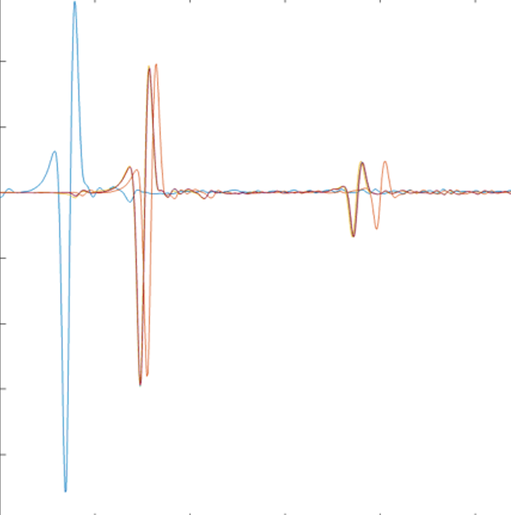

Terahertz Spectroscopy Measurements on Black Silicon
by
Jesper Graungaard Bertelsen
AU-ID: au689481, Study-ID: 202204617

Bachelor’s Thesis
in
Electrical Engineering

Supervisor:
Pernille Klarskov

Co-Supervisor:
Rasmus Davidsen

Aarhus University, Department of Electrical and Computer Engineering
7. August 2026

Indholdsfortegnelse
Abstract 4
Introduction 4
Eksperimental setup 5
Methods and theory 6
Terahertz Time-domain Spectroscopy ( THz-TDS ) 6
The generation ( PCA ) 6
The detection ( PCA ) 7
Possible issues 9
Averaging 9
Modulation 11
Transmission through one layer 14
Transmission through a thin film 17
Effect of propagation in air. 20
New updated equation 20
Windowing 21
Calculations of uncertainty 25
Experimental results 26
Verifying the setup 26
Data gathering 29
Removing the reflection by windowing the signal. 32
Describing my signals in terms of refractive indices of the thin film. 33
Uncertainty. 35
Min / maxing the dimensions 36
New setup 38
Discussion 40
Conclusions 41
Bibliografi 41
Appendix 44
Fourier series representation. 44
Continuous time Fourier transform properties 44
Continuous time Fourier transform table 45
Discrete time Fourier transform properties 46
Discrete time Fourier transform table 47
Fourier transform of a square wave. 48
Electromagnetic waves passing through uniform plane. 50

Abstract
Terahertz time-domain spectroscopy (THz-TDS) is a non-destructive characterization technique capable of extracting optical properties of materials by measuring the transmitted THz electric field. This project investigates the applicability of THz-TDS for estimating the refractive index of thin films on top of wafers. A theoretical transmission model was derived and extended to account for propagation through the additional air path introduced by wafer etching. Furthermore, signal-processing techniques including time-domain windowing and lock-in detection were examined to understand their influence on the extracted material parameters. The modified transmission model produced more stable refractive-index estimates than the previous approach. However, considerable uncertainty remained, and some estimated refractive indices were outside physically realistic ranges. The project demonstrates both the potential and the limitations of THz-TDS for non-destructive thin-film characterization and provides a basis for further improvement of the extraction methodology.

Introduction
Increasing environmental challenges have created a growing demand for advanced analytical techniques. The problems of tomorrow doesn’t belong to one field of work only, but rather how we’ll be able to work together, for the greater good. Researchers all over the globe, as well as others, are trying to solve these challenges, and with properties of THz radiation, soon they might be able to.
THz radiation benefit many field of science having special properties. ”The spectral range between 0.1 THz and 10 THz ( $3,3cm^{-1}-333cm^{-1}$ ) is an important region for low frequency dielectric relaxation and vibrational spectroscopy of liquids, such as water, methanol, ethanol, propanol, and others” [1]. It’s due to properties within molecules and material science and more that motivates us to make use of the THz radiations analytically.
Realizing THz radiation comes with its own issues, however. A THz signal duration in ps, with modern digital electronics dealing with rise and fall times in the ns region, simply will not suffice.
Instead optics is being used in smart and clever ways, that makes it possible to sample with sub picosecond time resolutions. With the solution, its own problems. Moving something of higher frequencies down to lower frequencies causes our signal to be more affected by noise.
When all is set and stone and THz radiation, through THz - TDS, have been realized, its at ones disposal for analytics.
I will be utilizing THz - TDS to investigate the possibility of non-destructible scannings of materials of microscopic sizes. Tools are available for these dimensions, but will be destructible or slow. For research in solar panels or other wafers with these small of sizes, a glimpse by the eye isn’t enough, and that’s where THz - TDS could be used to make a quick, non-destructible scan. In theory.

Eksperimental setup
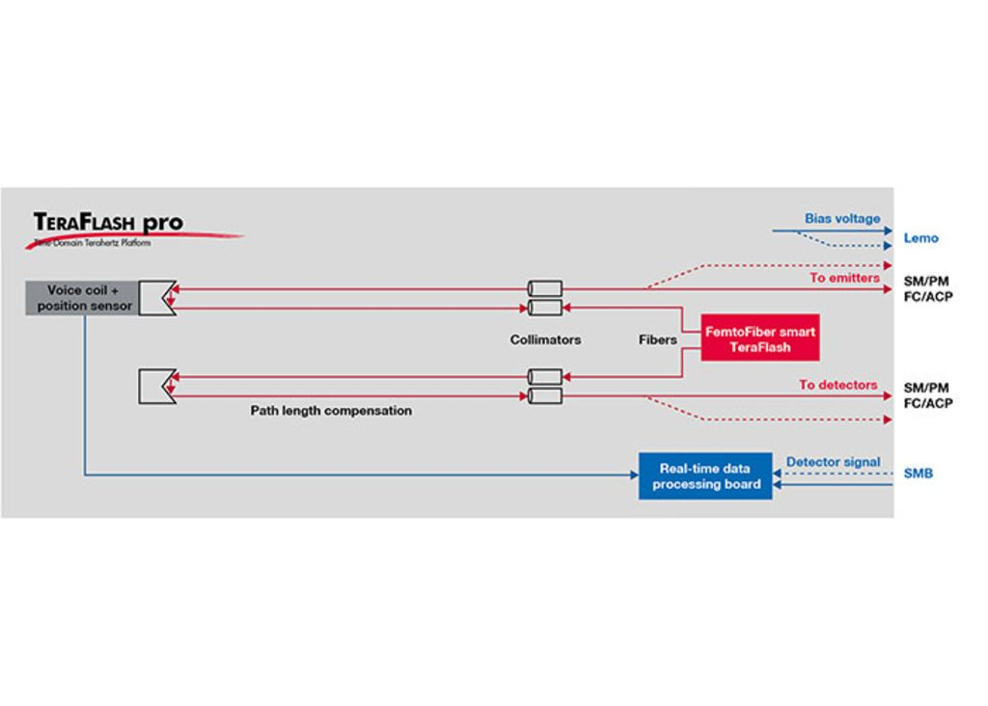
For the equipment, a TeraFlash pro by toptica will be used in collaboration with equipment to keeping the optically equipment in place, as well as one for adjusting the vertical position of the wafer.
The teraflash pro has in it a the $50fs$ laser pulse, which gives the time resolution of $∆t=0,05ps$.
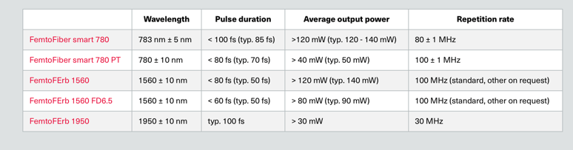

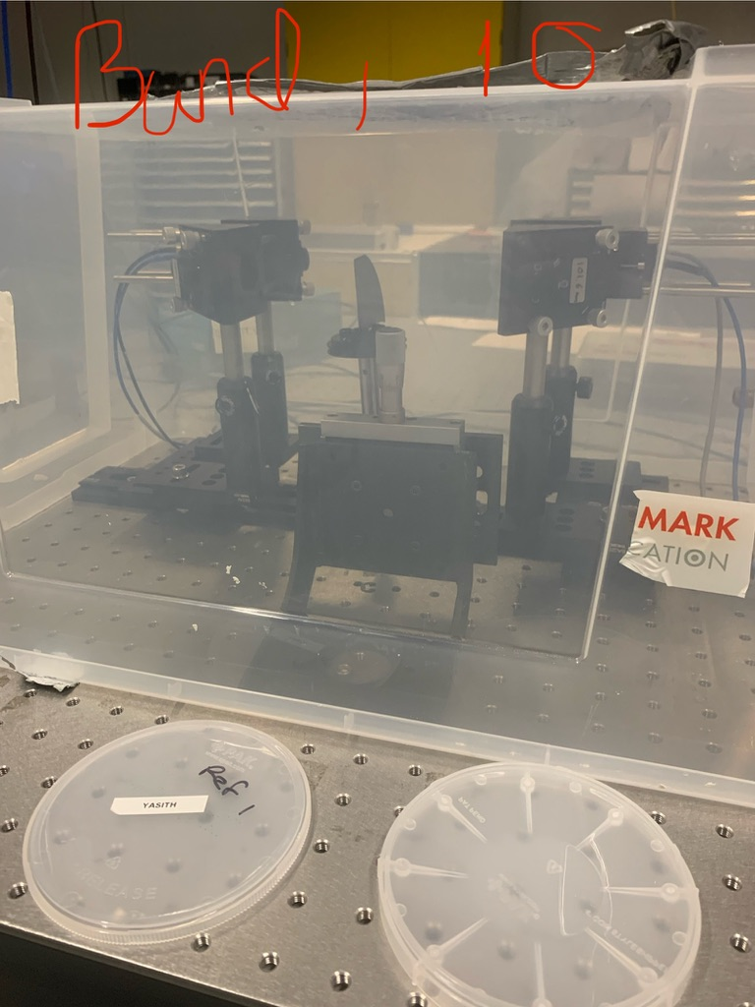
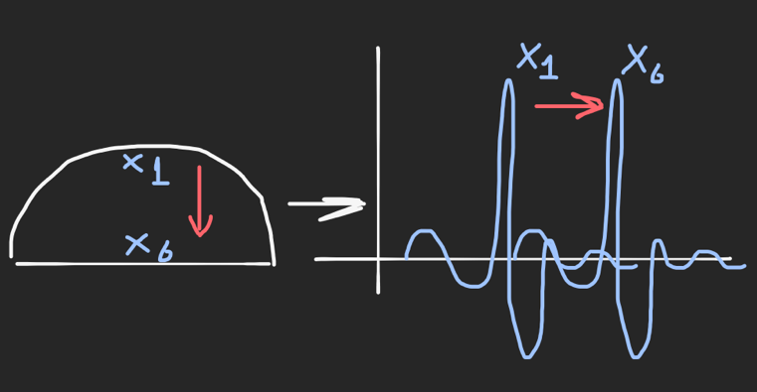
And my thesis was build on a more integrateable sampling, talking multiple sample datasets of the same wafer.
Figure 1: My setup
Figure 2: The thesis

Methods and theory

Terahertz Time-domain Spectroscopy ( THz-TDS )

The generation ( PCA )
For THz generation one can use a more industrial common laser in the fs range. That will give the THz radiation a duration in the ps range, and can have simplifying properties, when it comes to the detection [2] of the THz field. There exist several techniques of creating THz radiation. For my setup, PCA was the chosen one.
PCA stands for photo conductive antenna, and as the name suggest, a photon excites an antenna which makes it more conductive, resulting in a current flow. In THz - TDs the electric field becomes a function taking this current as a variable. In PCA two metal plates are put in parallel to one another. That can be done by lithografically fabricating it on a semiconductor, and biasing it with a bias voltage, that is insufficent for current flowing to. The bias should however be sufficient for the current to flow, when the laser of choice pumps it between the plates. The THz field can then be described as a function of time
$$E_{THz}\left(t\right)∝w_{0}·\frac{\sin\left(α\right)}{r}·\frac{d}{dt_{r}}·\left(I_{PC}\left(t_{r}\right)\right)$$
$α$ is the angle of observation, $w_{0}$ is a diameter of the metal plates and $t_{r}$ is the retarded time, being the time variable time shifted by the time it takes for light to occur at the observer $t_{r}=t-\frac{r}{c}$ [2]. By this relationship we can tell, that the THz field is a function of the change in current across the metal plates. We can also tell, that the THz field is highly divergent by the $\sin\left(α\right)$ faktor, being at min and max values at $±90°$. This is something to take into consideration when setting up the THz - TDS station.
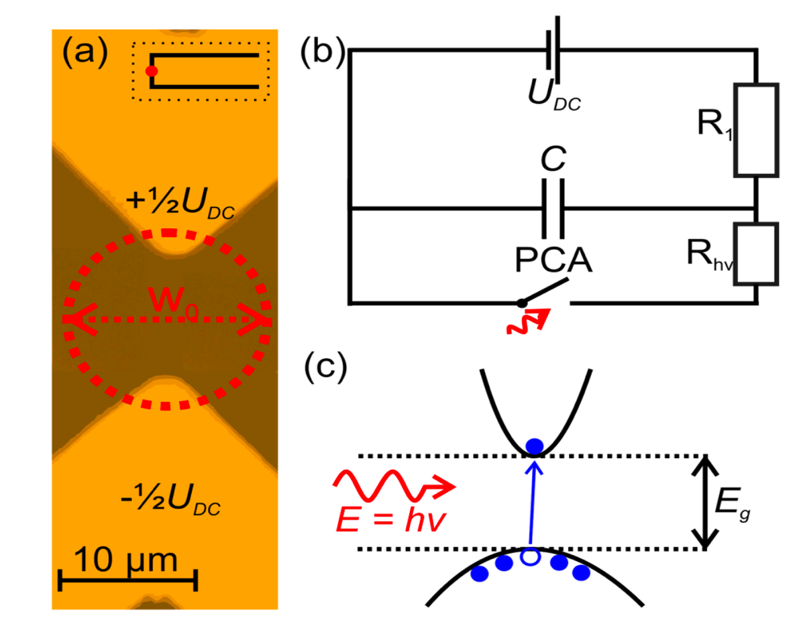

Figure 3: Figure taken from the tutorial of J. Neu and Charles. A. Schmuttenmaer:
(a) Optical microscope image of a dipole photoconductive antenna (PCA). The laser spot is focused in the gap, while a bias voltage is applied between the metallic contacts. Inset: overview of a simplified antenna, the red dashed circle indicates the location of the laser illumination. (b) Simplified electrical circuit diagram illustrating the basic concept of the photoconductive switch. (c) Simplified band scheme illustrating the photoexcitation by a photon with $E=hv>E_{g}$ i.e., larger than the bandgap.

For the case of a femtosecond laser pulse the duration of the THz field will be in the range of picoseconds [2].

The detection ( PCA )
As with the generation of THz fields, the detection has different ways of retrieving the same results as well [3]. In my setup, the equipment uses PCA for the detection.
For the detection of the THz field using PCAs, similar setups to the generation of the THz fields can be used. However instead of biasing the circuit, the emitted THz field at the generation site, should have equal energy as the required energy at the output site [4]. That is, if we’ve succeded in focusing the light, such that everything at the emitter enters the detector. It’s also an assumption, that no loss occurs along the way. A practical design should then take those things into account.

As described in the tutorial of Jens Neu and Charles A. Schmuttenmaer, the femtosecond laser will result in a change of current in the femtosecond range, but the emitted THz field will be in the picosecond range. As the laser within my equipment is also in the femtosecond range, this holds for my setup as well [5].
Issues arives when trying to sample such small time intervals using conventional electronics. Electrical signals has rise and fall times in the regions of nanoseconds. Requiring picoseconds resolution then means, that conventional electronics doesn’t have what it takes to sample useful information. Instead of the electronics having to sample faster than it’s able to, we tend to optics to solve the requirement of picosecond resolution.
At a given time, the signal can be described as:
$$S\left(t\right)∝I_{opt}\left(t\right)·E_{THz}\left(t\right)$$
As conventional detectors are to slow, our solution is then to tend to another relationship:
$$S\left(t_{1}\right)∝I_{opt}\left(t_{1}\right)⋆E_{THz}\left(t\right)$$
Where $E_{THz}\left(t\right)$ comes from the generation side, and the $I_{opt}$ comes from the intensity of the input laser. By convolution we get a relationship towards a message at a given time. Due to the duration of the laser is in fs and the duration of the THz field being in ps, the optical intensity would act as an weighted impulse. If we only care about the proportionality we can say that:
$$S\left(t_{1}\right)∝I_{opt}\left(t_{1}\right)⋆E_{THz}\left(t\right)≈δ\left(t_{1}\right)⋆E_{THz}\left(t\right)$$
$$S\left(t_{1}\right)∝E_{THz}\left(t_{1}\right)$$
That gives us a relationship, that we can use for sampling [5].

At a set time $t_{1}$, we will get the information corresponding to the electric field at $t_{1}$. A timeshift of the input laser can then result in information about different points on the electric field. As
$$s=t·c$$
For s being the path length, c the speed of light, we have a relationship between distance required as a function of time resolution required.
For a laser in the femtosecond region resulting in picosecond THz radiations, the lengths required to achieve those resolutions are in the millimeter range. That makes it sensible to small ranges, and computer-controlled position stages can be used to fulfill those requirements. [5]

Possible issues
There are a lot of different source of noise. Some of them are being discussed in the “Tutorial: an introduction to terahertz time domain spectroscopy ( THz-TDS )”, it being about DC noise coming from the environment around one, a laser being nonlinear and its outputs varying in time [6], as well as water being reactive at the THz frequencies, causing them to vaporize [5]. The water vaporizing can be done outside of the detection, simply by changing the environment surrounding it. But the noise at the detector needs to be dealt with in a different way.

Averaging
A simple and practical way to remove noise, that’s been used in different fields of electronics, is averaging. It dims high frequency components and rather looks at the general trend… though varies in how much, depending on how you design it.
As with a lot of things in engineering, theory is described in time domain, but realizing that can sometimes be complicated and simpler if one samples it to the discrete time domain. For the equipment that was available for me, it averaged discretely, and rather than ask for a time duration to average the measurement across, I was asked for how many datapoints I wanted to average the measurement across. Two sides to the same solution, but done in different ways, bringing different problems later on.

For normal averaging in time domain, it can be described by
$$A_{avg}=\frac{1}{T}\int_{0}^{T}{A\left(t\right)}dt$$We don’t sample the signal directly in electronics with time, but rather using optics to vary the time points of the THz signal. That can be confusing when trying to explain what’s a measure of time, and what’s a measure of the THz signal. As with conventions, it’s been chosen at some point. In Time Domain Spectroscopy, it’s been chosen that $t_{i}$ denotes the timepoint i, of the THz signal. I’ll add a variable $τ$ being a measure of time. $τ_{i}$ will equal the center of time of which $t_{i}$ is being measured. A measurement is then from $τ_{1}-\frac{T}{2}→τ_{1}+\frac{T}{2}$ and $τ_{1}+\frac{T}{2}-\left(τ_{1}-\frac{T}{2}\right)=T$. Then
$$F\left(t_{1}\right)=\frac{1}{T}\int_{τ_{1}-\frac{T}{2}}^{τ_{1}+\frac{T}{2}}{E_{THz}\left(τ\right)dτ}$$
Ideally this is the averaging would work, but switching between stages isn’t discrete, but usually’s done by mechanically displacing mirrors to desired positions, which has a constant speed. That means while to integration is taking place, the datapoint of measure is moving. What’s happening is kinda like trying to take a photo while moving. It gets blurry, and this blur in the TDS can be described as convolution by a gaussian function.
$$E\left(t\right)⋆\frac{1}{σ}·e^{-\frac{t^{2}}{2σ^{2}}}$$
Where $σ=τ·v$, $τ$ is a time constant, and $v$ is the velocity of the displacement in terms of movements $ps/s$, to better describe moving from timepoint to timepoint for the THz signal.
The time constant describes the period of measuring, and usually after 3-5 time constant, most of the signal has been measured. The slower the period of measuring the better the SNR. However as it’s not only the time constant that determines the final value, but also the speed of which the scanner is moving. The variables must then be picked in terms of each other, to not blur different time points with each other.
A typical value of time constant could be $τ=30ms$. Having a scan velocity of $v=\frac{10ps}{s}$, and the signal has been final after $\left[3τ;5τ\right]$, the measurement would have been finished after the scanner having moved the delay line $\left[3τ;5τ\right]·v=\left[0,9ps;1,5ps\right]$, worth of displacement at the delay line.
Having a time resolution in the THz signal of $0,05ps$ would mean, that during the measuring time, I would average across $N=\frac{\left(1,5-0,9\right)}{0,05}·\frac{ps}{ps}=12$, amount of time points in the THz signal. [7]
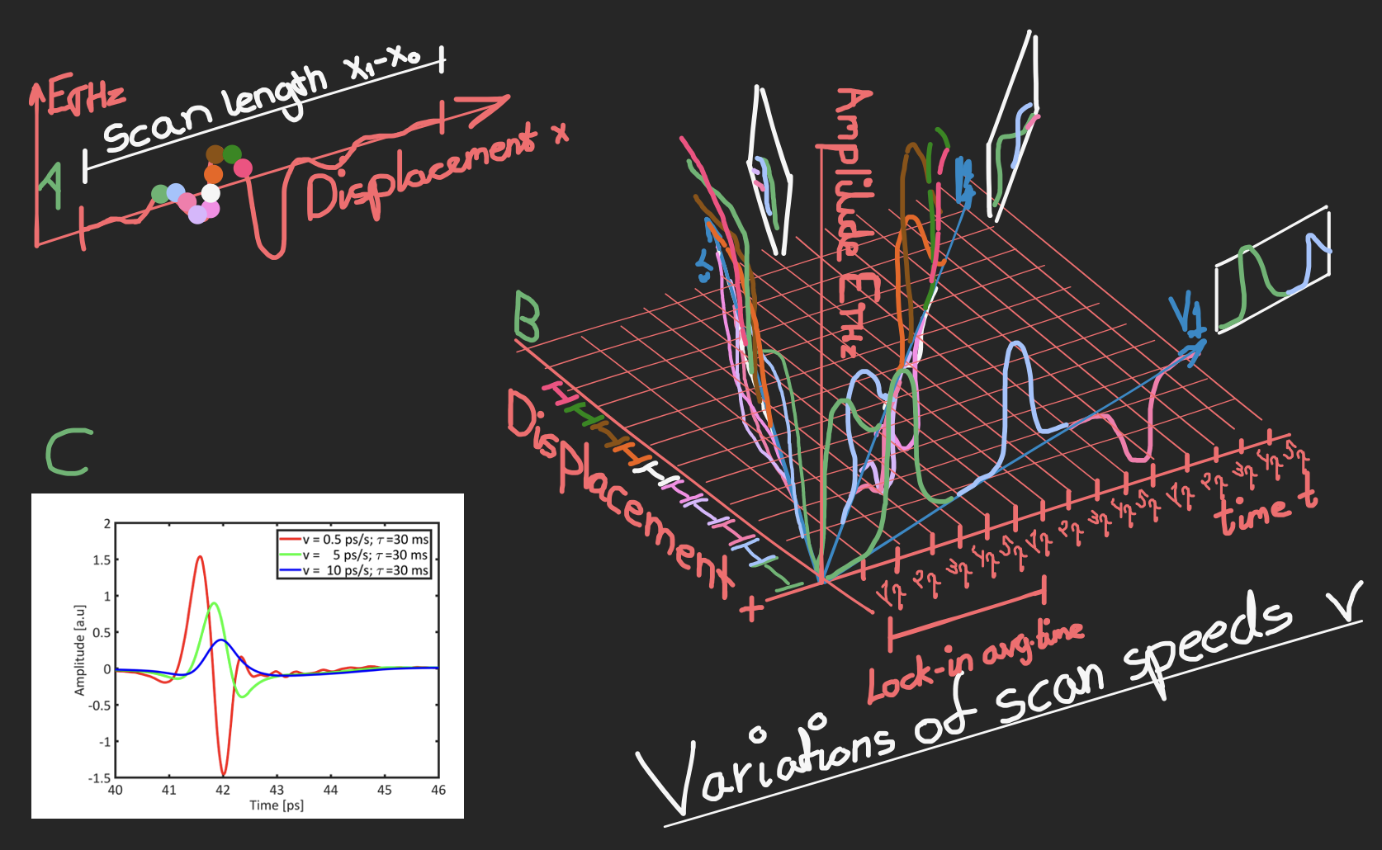
Averaging across multiple time points removes useful information of the time points, and that’s why it all needs to be picked in terms of each other.
Figure 4: A. The displacement of the delay line, causing different time points to be at measure. B. a try to visualize a variance in the scan speed parameter when averaging in time, with a moving delay line. As with photo images taken while moving, the information will become blurry. Every measurement is broadened out on different timepoints, and each timepoint weighs less, with the scanning speed increasing. C. A figure taken from the tutorial of THz TDS by Jens Neu and Charles A. Schmuttenmaer, which shows the full signal having been sampled, but at different scanning speeds [7].

The right choice of setup matters, and it’s even more clear, when one takes it into the frequency domain.
As
$$E\left(t\right)⋆\frac{1}{σ}·e^{-\frac{t^{2}}{2σ^{2}}} \begin{matrix}F \\ ↔\end{matrix} E\left(ω\right)·e^{-\frac{1}{2}·ω^{2}σ^{2}}$$Taken from the tutorial to THz TDS [7].
We see that the exponential function has a factor in the negative exponent, that’s $-\frac{σ^{2}}{2}$. It’s known that for negative exponents, the bigger the constant, the sharper the feature.
That means, for the speed increasing the steeper the slopes of the low pass filter effect of the scan.
As with the optical method and the lock in time average measurement approach, sampling becomes far easier, as we aren’t required to sample in the ps range. Cheap equipment can work wonders with this approach, as the bandwidth doesn’t have to be wide. In figure 3.C, the tutorial used frequencies of 128Hz and 512Hz. That’s great for the need for equipment, but in terms of the noise, it brings new challenges. That’s what motivates the next approach.

Modulation
A lot of noise is occurs around DC, and the ranges of frequencies, that this sampling approach is at isn’t far of. Trying to filter out noise from frequencies close to the desired frequencies requires sharp bandstops or is simply impossible, if the noise is at the frequencies of desire. Instead we modulate our THz signal. We do that by turning off the THz generation at different frequencies. That can be done by powering down the bias voltage at the modulation frequency, such that there can’t be any THz signals emitted. Blocking the signal by disturbing the path of travel at the modulated frequency or in other ways, ensuring that the THz signals are propagating at the modulated frequency. [8]
Our motivation towards alternating the generation between being on and off comes from properties of systems as well as properties between time domain and frequency domain.
Multiplying a signal in time domain equals the frequency responses convoluted together. The same is true for frequency domain towards time domain. And what we want is to move our frequencies of desire away from the DC. One way of doing this is by multiplication by a cosine signal.
$$f\left(t\right)·\cos\left(ω_{m}t\right) \begin{matrix}F \\ ↔\end{matrix} F\left(jω\right)⋆π\left[δ\left(ω+ω_{m}\right)-δ\left(ω-ω_{m}\right)\right]$$
And by the property, that convolution by impulses causes the other function to have the time shift / frequency shift of the impulses, become its own time shifts / frequency shifts .
That makes
$$f\left(t\right)·\cos\left(ω_{m}t\right) \begin{matrix}F \\ ↔\end{matrix} π·\left(F\left(jω+ω_{m}\right)-F\left(jω-ω_{m}\right)\right)$$That’s the idea.
In practice however, it may be easier to realize a square wave function. It can be constructed by a fourier series of constant coefficient that together are able to reconstruct a square wave function. So they can kindda be a solution aswell.
A frequency response of a square wave has been calculated in the appendix, Fourier transform of a square wave, to be:
$$X\left(jω\right)\left(a\right)=\left\{\begin{aligned} 0, k≠0 and even \\ \frac{2v_{Bias}}{k}·j, k≠0 and odd \\ π·v_{Bias}, k=0 \end{aligned}\right\}·δ\left(ω-kω_{0}\right)$$
As seen, they to have impulses discrete places in their frequency spectra. What differs is, that a square wave has infinite amount of impulses in the frequency spectra, as well as they being smaller and smaller the further the frequency sample of choice is from $ω=0$. $ω_{0}$ is the $\frac{2π}{T}$ for T being the period of the square wave. The inverse of the period of the square wave is our modulation frequency. $ω_{0}=2πf_{m}=ω_{m}$.
$E_{THz}\left(t\right)·square\left(t\right) \begin{matrix}F \\ ↔\end{matrix} E_{THz}\left(jω\right)⋆\left\{\begin{aligned} 0, k≠0 and even \\ \frac{2v_{Bias}}{k}·j, k≠0 and odd \\ π·v_{Bias}, k=0 \end{aligned}\right\}·δ\left(ω-kω_{m}\right)$
The most information kept would be at $k=1$. That would mean that by a square wave, we can move our signal by $ω_{m}$, for the amplitude of the frequencies being multiplied by $2v_{Bias}·j$. Where $v_{Bias}$ is highest value for the square wave, indicating it being a logic HIGH.
For our THz signal being around some modulation frequency $ω_{m}$ now, but the noise still around DC, what’s next can be done differently. One can make a highpass to filter out the DC area, but sampling frequencies around DC would make for the simplest solution. Trying to solve two problems at once, we’ll then modulate our signal having been detected at the PCA [8].
For now, its information can be described as
$$s\left(t\right)∝E_{THz}\left(t\right)·square\left(t\right)+n\left(t\right)$$
And for its spectra it can be described by
$$s\left(jω\right)∝ E_{THz}\left(jω\right)⋆\left\{\begin{aligned} 0, k≠0 and even \\ \frac{2v_{Bias}}{k}·j, k≠0 and odd \\ π·v_{Bias}, k=0 \end{aligned}\right\}·δ\left(ω-kω_{m}\right)+n\left(jω\right)$$But if I modulate it once more, this time by a cosine wave.
$$s\left(t\right)·\cos\left(ω_{m}t\right)∝\cos\left(ω_{m}t\right)·\left(E_{THz}\left(t\right)·square\left(t\right)+n\left(t\right)\right)$$
$s\left(jω\right)⋆π·\left[δ\left(ω+ω_{m}\right)+δ\left(ω-ω_{m}\right)\right]∝\left( E_{THz}\left(jω\right)⋆\left\{\begin{aligned} 0, k≠0 and even \\ \frac{2v_{Bias}}{k}·j, k≠0 and odd \\ π·v_{Bias}, k=0 \end{aligned}\right\}·δ\left(ω-kω_{m}\right)+n\left(jω\right)\right)⋆π·\left[δ\left(ω+ω_{m}\right)+δ\left(ω-ω_{m}\right)\right]$
That would make for scaling by $π$ and frequency shift by the modulation frequency.
$…∝\left( E_{THz}\left(jω\right)⋆π·\left\{\begin{aligned} 0, k≠0 and even \\ \frac{2v_{Bias}}{k}·j, k≠0 and odd \\ π·v_{Bias}, k=0 \end{aligned}\right\}·(δ\left(ω-kω_{m}+ω_{m}\right)+δ\left(ω-kω_{m}-ω_{m}\right)+π·(n\left(j\left(ω+ω_{m}\right)+j\left(ω-ω_{m}\right)\right)\right)$
$…∝E_{THz}\left(jω\right)⋆(π·v_{Bias}δ\left(ω\right)+\sum_{k=-∞}^{∞}{j\frac{2v_{Bias}}{k}}·\left(δ\left(ω-ω_{m}\left(k-1\right)\right)+δ\left(ω-ω_{m}\left(k+1\right)\right)\right)$
For large enough k’s, each $kω_{m}$ can be said to have been affected by both the delta functions. For the amplitude of each being a common one, sum of all k’s can be described by.
=========================================================
$…∝E_{THz}\left(jω\right)⋆\left(π·v_{Bias}δ\left(ω\right)+2·\sum_{k=-∞}^{∞}{j·\frac{2v_{Bias}}{k}}·δ\left(ω-kω_{m}\right)\right)$
$…∝E_{THz}\left(jω\right)⋆\left(π·v_{Bias}δ\left(ω\right)+2·\frac{2v_{Bias}}{k}·δ\left(ω\right)\right){\left.​\right|}_{-ω_{m}<ω<ω_{m}}$
=========================================================
By that, frequencies due to the square wave into cos modulation are moved to DC
This is exactly what we wanted to make use of averaging and its low pass properties. Modulating at the generation, then detecting, then modulating at the Lock-in amplifier, and then averaging it.
Next thing is sampling, but I won’t get into much details on how to do that. Rather the previous steps have made it significantly easier to realize. Commonly Sample and Hold ( S&H ) is used for sampling, sampling the value at a given timepoint keeping that value, and only changing values at the next timepoint that is being sampled. But as a sideeffect to our lock in time averaging, one could take advantage of that, and then sample the end value of it. That would act more like an Integrate and Dumb sampling approach.

Transmission through one layer
We’ve gotten a setup, but how do we now make use of the THz-TDS? What we’ve essentially found is that the PCA detector receives a current at excitation, and we’re able to describe it by its electric field. What could be interesting to know is how the relationship between the electric field having gone through a media, versus when it hasn’t.
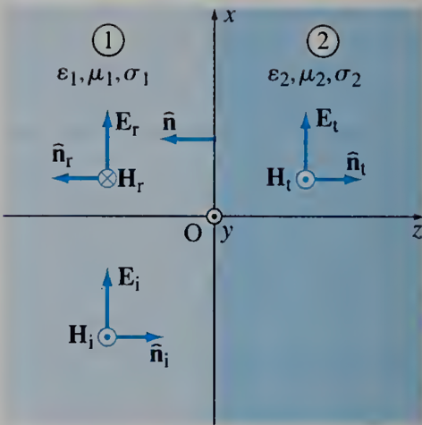
Initially, the incident beam propagates all the way to the receiving PCA detector.
For the transmitted beam coming out of the media it hasn’t. Rather some of it has been transmitted all the way through the media. Some of it has been reflected back, and some of it has been through both within the media multiple times. We don’t just talk about the transmission of the beam entering the PCA, we talk about the sum of transmission beam being incident at the PCA detector.
Imagine the beam being incident normal to a uniform surface. Furthermore the beam can be approximated to be a plane wave. Then
$E_{x}=E_{0}·e^{-γz}$
describes the electric field, for x being the direction in which the electric field travels. For the rest of the derivation, I’ll be talking just about the size of the electric field, rather than its direction.
Instead of describing it implicit in terms of it amplitudes, a relationship between input and output can be described.
The relationship can be described by the wave impedances for the two medias.
$Γ=\frac{E_{r0}}{E_{io}}=\frac{η_{2}-η_{1}}{η_{1}+η_{2}}$
Figure 5: The image used by for the derivation of the transmission and reflection at a boundary [9].
$τ=\frac{E_{t0}}{E_{i0}}=\frac{2η_{2}}{η_{1}+η_{2}}$
Where $Γ_{ij}$ describes the rate of reflection of a beam being incident from media i into media j. $τ_{ij}$ represents the same medias, but is the rate of transmission rather [9].

How a wave propagates through a media, is described by the propagation constant.
$γ=α+jβ$ [10]
Where $α$ is known as a attenuation constant, while the $β$ is known as the phase constant. For lossless propagation, the propagation constant can be described only by its phase constant.
$γ=jβ$
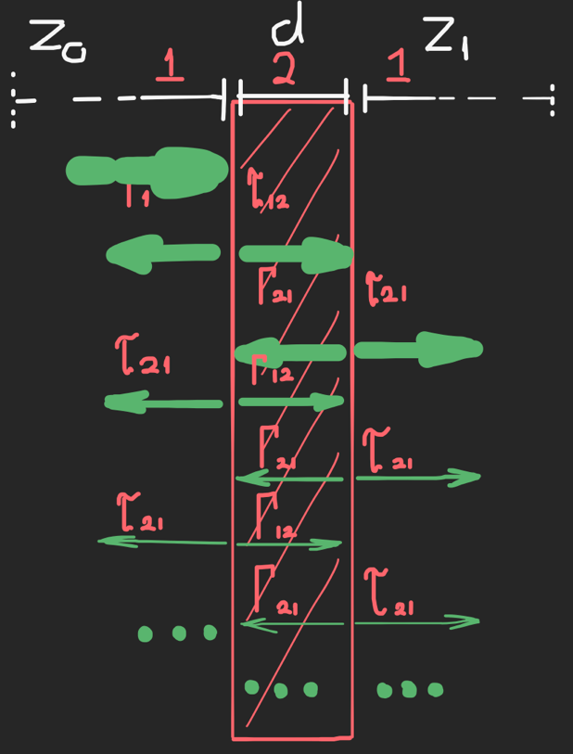
Now for analyzing the way of travel of the electromagnetic wave through all of its propagation.
Our reference beam can be described as:
$E_{ref}=E_{0}·e^{-jβ_{air}z_{0}}·e^{-jβ_{air}d}e^{-jβ_{air}z_{1}}$
As it’s only traveling in air.
For the propagation of THz through a sample, that we put in its way, it can be described as.
$E_{sam1}=E_{0}·e^{-jβ_{air}z_{0}}·τ_{12}·e^{-jβ_{sam}d}·τ_{21}·e^{-jβ_{air}z_{1}}$
As mentioned the transmission isn’t only due to first transmisison, but also those that’ve been reflected inside the media, for then later to be transmitted.
Given wafers of size $523,92μm$as they were for my setup, the next transmission will undergo an optical length of
$L=2·523,92μm$
As the speed of electromagnetic waves can be described by:
$v=\frac{c}{n}$
And
$L=v·t, t=\frac{L}{v}$
Then the time it takes can be written as:
$t=\frac{L}{c}·n$
$t≈\frac{2·523,92 }{3}·\frac{{10}^{-6} m}{{10}^{8}\frac{m}{s}}·3,43≈1,198·{10}^{-11}·s$
For an approximation of the refractive index at these wavelengths to be 3,43.
Then for every 12ps a new, transmission will be had. Since we have a setup with a resolution of $∆t=0,05ps$ due to the delay lines. Transmission will be had for every $\frac{12ps}{0,05ps}=240$ time points. Furthermore the THz transmission has a duration of about 4ps. Differentiation of transmission is then easy, and done by windowing later at signal processing.
Figure 6: Propagation through uniform wafer
A transmission function will then tell the relationship between.
$T=\frac{E_{sam1}}{E_{ref}}=\frac{E_{0}·e^{-jβ_{air}z_{0}}·τ_{12}·e^{-jβ_{sam}d}·τ_{21}·e^{-jβ_{air}z_{1}}}{E_{0}·e^{-jβ_{air}z_{0}}·e^{-jβ_{air}d}e^{-jβ_{air}z_{1}}}=τ_{12}τ_{21}·e^{j·\left(β_{air}-β_{sam}\right)·d}$
The phase constant depends on the wavelength at the relation
$β=\frac{2π}{λ}$ $←$ Phase constant in terms of wavelength [11]
$v=fλ$ $←$ Electromagnetic waves in terms of wavelength and frequency [12]
$v=\frac{c}{n}$ $←$ Speed of waves in terms of speed of light and refractive indices. [13]
Using the last two equations:
$λ·f=\frac{c}{n}$
$λ=\frac{c}{n·f}$
Inserting in the equation of the phase constant.
$β=\frac{ω}{c}n$ $←$ $ω=2πf$
Substituting it all into our transmission function:
$T=τ_{12}τ_{21}·e^{j·\frac{ω}{c}·\left(n_{air}-n_{sam}\right)·d}$
$∆ϕ=\frac{ω}{c}·\left(1-n_{sam}\right)·d$
================
$n_{sam}=1-∆ϕ·\frac{c}{ωd}$, $←$ Follows the negative convention .
================
Or had I chosen the positive convention:
$\frac{E_{sam}}{E_{ref}}=\frac{e^{j\frac{ω}{c}·n_{sam}}}{e^{j·\frac{ω}{c}·n_{air}}}=e^{j\frac{ω}{c}·n_{sam}}e^{-j·\frac{ω}{c}·n_{air}}=e^{j·\frac{ω}{c}·\left(n_{sam}-n_{air}\right)}$
================
$n_{sam}=1+∆ϕ·\frac{c}{ωd}$, $←$ Follows the positive convention.
================
Whether one uses the positive or negative convention doesn’t play that huge of a roll, as long as one is consistent with it all the way through. Engineers might use the negative convention, $e^{-γz},$ the most whereas physicists might use the positive, $e^{γz}$, the most. For my setup, folks before me had used the positive convention, so I stuck with that.

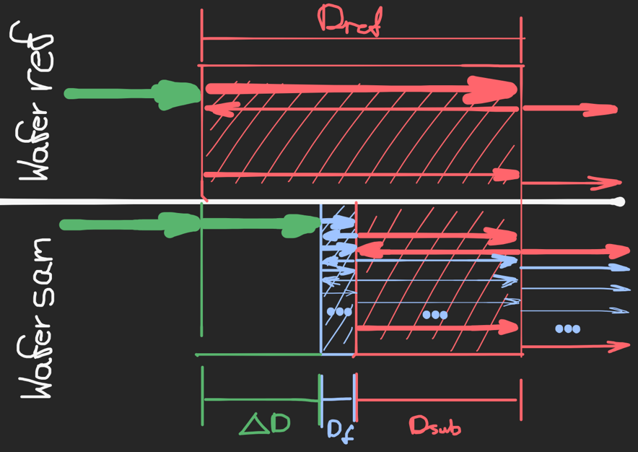
Transmission through a thin film
Figure 7: Propagation through, top : Uniform wafer, bottom: Our samples, having undergone etching. Reflections within the thin film is impossible for us to differentiate between. Instead we take the sum of all
Illustration trying to illustrate what contributes to our transmission. For our reference but also for it later having been etched.
For our reflections to reach transmission for our reference wafer, it would have to travel propagate a distance of $L=2·D_{ref}$. This was shown in the transmission through one layer to be $t≈11,98ps$. The conclusion was, that one would be able to differentiate between transmission due with the time resolution at setup.
Transmission can then be described by:
==========================
$E_{ref}=E_{0}·τ_{13}·e^{γ_{ref}·d_{ref}}·τ_{31}$
==========================
Where $E_{0}$ is the electric field at entry, $τ_{ij}$ describes the ratio of the signal being transmitted the incident beam coming from media i and going towards media j and $γ_{ref}$ determining the phase due to propagation inside a media. It’s all in the direction of propagation of the electric field.
For our etched sample, reflections will cause transmission for every $L=2·d_{f}$ traveled within the thin film media. Checking at minimum values. The thin film being bounded to have a refractive index within $\left[1;3.43\right]$.
The equation for time in terms of length and refractive index was derived for the transmission of through one lay to be: time inbetween transmission for our minimum size of film will then be:
$t=\frac{L}{c}·n, t=\frac{2·d_{f}}{3}·\frac{1}{{10}^{-8}}·n=\frac{2·1,1}{3}·\frac{{10}^{-6}}{{10}^{-8}}·1≈0,0073ps$ $←$ evaluated for min $d_{f}$ and $n$.
A time resolution of $∆t=0,05ps$ will be insufficient for differentiating between direct and later transmissions. Instead, deriving in terms of sum of transmission at a measured time point would yield better results. The etching however causes a depth over the whole surface of the wafer, so the maximum height of the film won’t be the maximum depth, the reference wafer having been etched by. These effects will be added later.
$E_{sam0}=E_{0}·τ_{12}·e^{γ_{f}d_{f}}·τ_{23}·e^{γ_{sub}·d_{sub}}·τ_{31}$
$E_{sam1}=E_{0}·τ_{12}·e^{γ_{f}d_{f}}·Γ_{23}·e^{γ_{f}·d_{f}}·Γ_{21}·e^{γ_{f}·d_{f}}·τ_{23}·e^{γ_{sub}·d_{sub}}·τ_{31}$
For $Γ_{ij}$ being incident from media i and reflection of the boundary going into media j.
$E_{sam2}=E_{0}·τ_{12}·e^{γ_{f}d_{f}}·{\left(Γ_{23}·Γ_{21}·e^{2γ_{f}·d_{f}}\right)}^{2}·τ_{23}·e^{γ_{sub}·d_{sub}}·τ_{31}$
A general equation sees as:
$E_{samk}=E_{0}·τ_{12}·e^{γ_{f}d_{f}}·{\left(Γ_{23}·Γ_{21}·e^{2γ_{f}·d_{f}}\right)}^{k}·τ_{23}·e^{γ_{sub}·d_{sub}}·τ_{31}$
$E_{sam}=\sum_{K}{{E_{sam}}_{k}}=E_{0}·τ_{12}·e^{γ_{f}d_{f}}·\sum_{k=0}^{∞}{{\left(Γ_{23}·Γ_{21}·e^{2γ_{f}·d_{f}}\right)}^{k}}·τ_{23}·e^{γ_{sub}·d_{sub}}·τ_{31}$
Has an geometric sum, that can be substituted.
$E_{sam}=E_{0}·τ_{12}·e^{γ_{f}d_{f}}·\frac{1}{1-Γ_{23}·Γ_{21}·e^{2γ_{f}·d_{f}}}·τ_{23}·e^{γ_{sub}·d_{sub}}·τ_{31}$
The transmission and reflection coefficients being described by:
$τ_{ij}=\frac{2η_{j}}{η_{i}+η_{j}}, Γ_{ij}=\frac{η_{j}-η_{i}}{η_{i}+η_{j}}$ [9]
$η$ represents the wave impedance, and may also be known as Z in when talking in with context of waves. It can be described by:
$η=Z_{0}·\frac{μ_{r}}{n}$ [14]
$Z_{0}$ is a constant of the intrinsic vacuum wave impedance. For silicon being our material of use, where $μ_{r}≈1$:
$η=\frac{Z_{0}}{n}$
$τ_{ij}=\frac{2·\frac{Z_{0}}{n_{j}}}{\frac{Z_{0}}{n_{i}}+\frac{Z_{0}}{n_{j}}}=\frac{2·\frac{1}{n_{j}}}{\frac{1}{n_{j}}·\left(\frac{n_{j}}{n_{i}}+1\right)}=\frac{2}{\frac{1}{n_{i}}\left(n_{j}+n_{i}\right)}=\frac{2n_{i}}{n_{j}+n_{i}}$
$Γ_{ij}=\frac{\frac{Z_{0}}{n_{j}}-\frac{Z_{0}}{n_{i}}}{\frac{Z_{0}}{n_{i}}+\frac{Z_{0}}{n_{j}}}=\frac{\frac{1}{n_{j}}-\frac{1}{n_{i}}}{\frac{1}{n_{i}}+\frac{1}{n_{j}}}=\frac{\frac{1}{n_{i}}·\left(\frac{n_{i}}{n_{j}}-1\right)}{\frac{1}{n_{i}}·\left(1+\frac{n_{i}}{n_{j}}\right)}=\frac{\frac{1}{n_{j}}·\left(n_{i}-n_{j}\right)}{\frac{1}{n_{j}}·\left(n_{j}+n_{i}\right)}=\frac{n_{i}-n_{j}}{n_{j}+n_{i}}$
$n_{1}=n_{air}≈1, n_{2}=n_{f}, n_{3}=n_{sub}=n_{ref}$.
Some algebra, cancelations and substitutions later, we are left with:
=======================================================
$τ_{ij}=\frac{2n_{i}}{n_{j}+n_{i}}, τ_{12}=\frac{2}{n_{f}+1}, τ_{13}=\frac{2}{n_{ref}+1}, τ_{23}=\frac{2n_{f}}{n_{ref}+n_{f}}$
$Γ_{ij}=\frac{n_{i}-n_{j}}{n_{j}+n_{i}}, Γ_{21}=\frac{n_{f}-1}{1+n_{f}}, Γ_{23}=\frac{n_{f}-n_{ref}}{n_{ref}+n_{f}}$
=======================================================
Substituting into my sample equation and rearranging it:
$E_{sam}=\frac{4n_{f}}{\left(-\left(n_{f}-1\right)·\left(n_{f}-n_{ref}\right)e^{d_{f}γ_{f}}+\left(n_{f}+1\right)·\left(n_{f}+n_{ref}\right)e^{-d_{f}γ_{f}}\right)}·E_{0}·τ_{31}·e^{d_{sub}γ_{sub}}$
Making a variable
$C=E_{0}·τ_{31}·e^{d_{sub}γ_{sub}}$
Assuming that propagation causes no loss, I can say that $γ_{f}=jβ_{f}=j\frac{2π}{λ}$
$v=λ·f$
$v=\frac{c}{n}$
$λ=\frac{c}{n·f}$
$γ_{f}=jβ_{f}=j\frac{2πf}{c}n_{f}=j\frac{ω}{c}n_{f}$
Substituting complex exponentials by their trigonometric expressions, expanding and reducing.
$E_{sam}=\frac{4n_{f}}{2·n_{f}·\left(n_{ref}+1\right)·\cos\left(\frac{d_{f}·n_{f}·ω}{c}\right)-2j·\left(n_{ref}+n_{f}^{2}\right)·\sin\left(\frac{n_{f}·d_{f}ω}{c}\right)}·C$
Using small angle approximation:
$E_{sam}=\frac{4n_{f}}{2·n_{f}·\left(n_{ref}+1\right)-2j·\left(n_{ref}+n_{f}^{2}\right)·\frac{n_{f}·d_{f}ω}{c}}·C$
===========================
$E_{sam}=\frac{2}{1+n_{ref}-j\frac{d_{f}ω}{c}·\left(n_{ref}+n_{f}^{2}\right)}·C$
===========================
$$E_{ref}=E_{0}·τ_{13}·e^{γ_{ref}·d_{ref}}·τ_{31}$$
Now for cancel some of the common variables we put transmission into relation with one another. That is our transmission function:
$T=\frac{E_{sam}}{E_{ref}}=\frac{2}{1+n_{ref}-j\frac{d_{f}ω}{c}·\left(n_{ref}+n_{f}^{2}\right)}·\frac{C}{E_{0}·τ_{13}·e^{γ_{ref}·d_{ref}}·τ_{31}}$
Unpacking C.
$T=\frac{2}{1+n_{ref}-j\frac{d_{f}ω}{c}·\left(n_{ref}+n_{f}^{2}\right)}·\frac{E_{0}·τ_{31}·e^{d_{sub}γ_{sub}}}{E_{0}·τ_{13}·e^{γ_{ref}·d_{ref}}·τ_{31}}$
$γ_{ref}=γ_{sub}$
$T=\frac{2}{1+n_{ref}-j\frac{d_{f}ω}{c}·\left(n_{ref}+n_{f}^{2}\right)}·\frac{1}{τ_{13}}·e^{γ_{ref}·\left(d_{sub}-d_{ref}\right)}$
Substituted:
$T=\frac{\left(n_{ref}+1\right)}{n_{ref}+1-\frac{jd_{f}ω\left(n_{f}^{2}+n_{ref}\right)}{c}}·e^{γ_{ref}·\left(-d_{ref}+d_{sub}\right)}$
$n_{f}=±\sqrt{\frac{c}{j·ω·d_{f}}·\left(\left(n_{ref}+1\right)-\left(n_{ref}+1\right)·\frac{n_{ref}·e^{γ_{ref}·\left(-d_{ref}+d_{sub}\right)}}{T}\right)-n_{ref}}$
$n_{f}=±\sqrt{\frac{c}{j·ω·d_{f}}·\left(n_{ref}+1\right)·\left(1-\frac{e^{γ_{ref}·\left(-d_{ref}+d_{sub}\right)}}{T}\right)-n_{ref}}$
===============================================
$n_{f}=\sqrt{\frac{c}{j·ω·d_{f}}·\left(n_{ref}+1\right)·\left(1-\frac{e^{γ_{ref}·\left(-d_{ref}+d_{sub}\right)}}{T}\right)-n_{ref}}$
Which can also be describe by:
$n_{f}=\sqrt{\frac{T·\left(1+n_{ref}-n_{ref}·\frac{j·ω·d}{c}\right)-\left(n_{ref}+1\right)·e^{γ_{ref}·\left(d_{sub}-d_{ref}\right)}}{T·\frac{iωd}{c}}}$
===============================================
But can one can have more calculational advantages as the other, as the high vector dimensions causes a lot of calculation to happen. I used the last mentioned for most of my signal processing. It wasn’t accountable for all the errors I had, but it contributed with some.
Those equation didn’t take propagation in the air into account.

Effect of propagation in air.
$e^{jγ_{air}·20μm}$
$\frac{2π}{λ}·d_{air}$
$\frac{2π}{c}·n_{air}·f·d_{air}$
$2π·n_{air}·f_{THz}·\frac{1}{3}·\frac{{10}^{12}}{{10}^{8}}·d_{air,m}·{10}^{-6}$
$f_{THz}·2π·\frac{1}{3}·\frac{{10}^{12}}{{10}^{8}}·d_{air,m}·{10}^{-6}≈0,02094·d_{air}·f_{THz}$
$H\left(d_{m},f_{THz}\right)≔0,02094·d_{m}·f_{THz}$
Me using the spectra at 0,8 -> 1,15THz. Its maximum impact will be for the highest of frequencies.
As well with the dimensions. Max of both max global max and min of both makes global min.
$\left[\begin{aligned}H\left(5;0,8\right) \\ H\left(20;1,15\right)\end{aligned}\right]≈\left[\begin{matrix}0,08376 \\ 0,4816\end{matrix}\right]·\frac{180°}{π}≈\left[\begin{matrix}4,799 \\ 27,59\end{matrix}\right]°$, accepting that as uncertainties, makes the deriving much simpler.

New updated equation
If I backtrack to the transmission function:
$T=\frac{E_{sam}}{E_{ref}}=\frac{\left(n_{ref}+1\right)}{n_{ref}+1-\frac{jd_{f}ω\left(n_{f}^{2}+n_{ref}\right)}{c}}·e^{γ_{ref}·\left(-d_{ref}+d_{sub}\right)}$
$T·e^{γ_{air}·∆d}=\frac{E_{sam}·e^{γ_{air}·∆d}}{E_{ref}}=\frac{\left(n_{ref}+1\right)}{n_{ref}+1-\frac{jd_{f}ω\left(n_{f}^{2}+n_{ref}\right)}{c}}·e^{γ_{ref}·\left(-d_{ref}+d_{sub}\right)}·e^{γ_{air}·∆d}$
Would have taken propagation in air into account. New variable is made:
$P_{air}=e^{γ_{ref}·\left(-d_{ref}+d_{sub}\right)}·e^{γ_{air}·∆d}=e^{j·\frac{ω}{c}·n_{ref}·\left(-d_{ref}+d_{sub}\right)}e^{j·\frac{ω}{c}·1·\left(d_{ref}-d_{sub}+d_{f}\right)}$
===============================$P_{air}=e^{j·\frac{ω}{c}·\left(n_{ref}-1\right)·\left(-d_{ref}+d_{sub}\right)}e^{j·\frac{ω}{c}·d_{f}}$
===============================
The solution remains the same form, but with the one phase term being different.
=====================================
$n_{f}=\sqrt{\frac{c}{j·ω·d_{f}}·\left(n_{ref}+1\right)·\left(1-\frac{P_{air}}{T}\right)-n_{ref}}$
=====================================

Windowing
A window takes a signal and transforms it. It is multiplied by a time signal which brings frequency modulating properties. By a window, one will then be able to change how the energy of a signal is distributed by its frequency components.
Instead of just changing the distribution of energy at frequencies, it’s also how we are able to differentiate between direct and later transmissions, for reflection within the substrate or reference.
We’ve found, that a transmission happens every 12ps. $N=\frac{12ps}{0,05ps}=240$. For every 240 sample, a new transmission will occur. As for each transmission, part of its energy is lost. The second transmission doesn’t affect the first transmission quiet as much as the first transmission affects the second transmission. Choosing the right amount of samples is then a matter of justifying when the second transmission interfers too much with the first one.
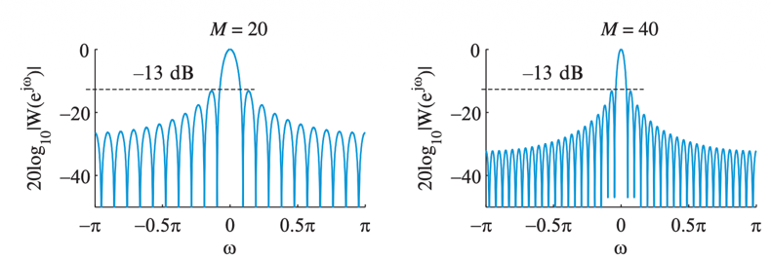
That’s a problem that may or may not be solved when choosing a window. Depended on which window function one choses, different samples will be weighted differently.
Throughout the experimental stage, both the square window has been used to try to verify previously found results as well as the Tukey window has been used for own experimental. The effects of these will follow below.
$w\left[n\right]=\left\{\begin{aligned}1, 0≤n≤M-1 \\ 0, else \end{aligned}\right\}$
Will equate to be a rect function of size M, but sample shifted by $\frac{M-1}{2}$.
Figure 8: The width of the rectangle window on how it affectst the sidelobes. Wider window, narrower around center frequency [27]
Square function
$w\left[n\right]=\left\{\begin{aligned}1, 0≤n<N \\ 0, else \end{aligned}\right\}=rect\left(\frac{n-\frac{N}{2}}{N}\right)$
$x\left[n-n_{0}\right]→^{F}e^{-jωn_{0}}X\left(e^{jω}\right)$ [15] Or
$x\left[n-n_{0}\right]→^{F}e^{jωn_{0}}X\left(e^{jω}\right)$ Depended on the phase shift convention.

$w\left[n\right]→^{F}e^{±jω·\frac{N}{2}}·\frac{\sin\left(ω·\left(\frac{N}{2}+\frac{1}{2}\right)\right)}{\sin\left(\frac{ω}{2}\right)}$ [16]
Corresponding to adding a linear phase.
For $M↑$ the spectral width decreases, by $M↓$ the spectral width increases.

Tukey window:
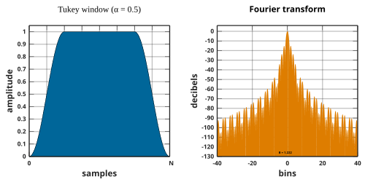
The tukey window has the benefits of the rectangle window, but without the problems of higher frequency components due to the discontinousies around the edges. That essentially means, that it’s better at diming frequencies away from the frequency components of choice.
$w_{1}\left[n\right]=\left\{\begin{aligned}\frac{1}{2}·\left(1-\cos\left(\frac{2πn}{αN}\right)\right), 0≤n≤\frac{αN}{2} \\ 1, \frac{αN}{2}≤n≤\frac{N}{2}\end{aligned}\right\}$ $CITATION Wik6 \backslash l 1030 [17]$
$w\left[n\right]=w_{1}\left[n\right]+w_{1}\left[N-n\right]$
Describes the window.
Describing it in terms of 2*2 piecewise functions, it gets more complex analytically. Computation wise its great. If I instead break it up in its 3 functions:
The rise function, the rectangle function and the fall function.
Figure 9: Tukey Window in time domain as well as its transform in the frequency domain. From Wikipedia on Window Functions
$w\left[n\right]=w_{1}\left[n\right]+w_{2}\left[n\right]+w_{3}\left[n\right]$
$w\left[n\right]=w_{1}\left[n\right]+w_{2}\left[n\right]+w_{1}\left[N-n\right]$
$↕$
$W\left(e^{jω}\right)=W_{1}\left(e^{jω}\right)+W_{2}\left(e^{jω}\right)+W_{3}\left(e^{jω}\right)$
Now the frequency response can be created by the first.
$w_{3}\left[n\right]=w_{1}\left[N-n\right]$
Using properties of systems.
$g\left[n\right]=w_{1}\left[-n\right] ↔ W_{1}\left(e^{-jω}\right)$
$w_{3}\left[n\right]=g\left[n-N\right]=w_{1}\left[-\left(n-N\right)\right]=w_{1}\left[N-n\right] ↔ G\left(e^{jω}\right)·e^{-jωN}$
$w_{3}\left[n\right] ↔ W_{3}\left(e^{jω}\right)=W_{1}\left(e^{-jω}\right)·e^{-jωN}$

$W\left(e^{jω}\right)=W_{1}\left(e^{jω}\right)+W_{2}\left(e^{jω}\right)+W_{1}\left(e^{-jω}\right)·e^{-jωN}$
The Tukey window has only real parts:
$X\left(e^{jω}\right)=X^{⋆}\left(e^{-jω}\right) , X^{⋆}\left(e^{-\left(-jω\right)}\right)=X\left(e^{-jω}\right)$
$W_{1}^{⋆}\left(e^{jω}\right)·e^{-jωN}=W_{1}^{⋆}\left(e^{jω}\right)·e^{-jωm}e^{-jωm}$
$W_{1}\left(e^{jω}\right)=W_{1}\left(e^{jω}\right)e^{-jωm}e^{jωm}$
$W\left(e^{jω}\right)=e^{-jωm}·\left(W_{2}\left(e^{jω}\right)e^{jωm}+\left(W_{1}\left(e^{jω}\right)e^{jωm}+W_{1}^{⋆}\left(e^{jω}\right){\left(e^{jωm}\right)}^{⋆}\right)\right)$
For
$L\left(e^{jω}\right)=W_{1}\left(e^{jω}\right)e^{jωm}$
Then
$W\left(e^{jω}\right)=e^{-jωm}·\left(W_{2}\left(e^{jω}\right)e^{jωm}+\left(L\left(e^{jω}\right)+L^{⋆}\left(e^{jω}\right)\right)\right)$
And for complex numbers
$\left(a+ib\right)+{\left(a+ib\right)}^{⋆}=a+ib+a-ib=2a$
And
We can say that the window
$W\left(e^{jω}\right)=W_{2}\left(e^{jω}\right)+e^{-jωm}·2Re\left\{W_{1}\left(e^{jω}\right)e^{jωm}\right\}$
$W\left(e^{jω}\right)=W_{2}\left(e^{jω}\right)+e^{-jωm}·2Re\left\{W_{1}\left(e^{jω}\right)\right\}$
Our rectangle function can be described from a rect function.
$h\left[n\right]=\left\{\begin{aligned}1, \left|n\right|≤N_{1} \\ 0, else\end{aligned}\right\}$
$w_{2}\left[n\right]=h\left[n-\frac{N}{2}\right]$
$↕$
$W_{2}\left(e^{jω}\right)=H\left(e^{jω}\right)·e^{-\frac{jωN}{2}}$
And we set $m=\frac{N}{2}$, then
$W\left(e^{jω}\right)=H\left(e^{jω}\right)·e^{-\frac{jωN}{2}}+e^{-\frac{jωN}{2}}·2Re\left\{W_{1}\left(e^{jω}\right)\right\}$
$W\left(e^{jω}\right)=e^{-\frac{jωN}{2}}·\left(H\left(e^{jω}\right)+2Re\left\{W_{1}\left(e^{jω}\right)\right\}\right)$
Without explicitly solving for the analytic expression for the window, we are able to say, that the response function will be the sum of twice the real part of the fourier transform of the rising edge function plus the fourier transform of the rectangle function. With that a linear phase is then added

Shifting of the window
We must then consider the shifting to be made on the window:
For sample shift equaling a linear phase in the frequency domain, as well as a multiplication in time domain equalling a convolution in frequency domain. More over the samples in our signals are sample shifted as well, we are left with:
$X\left(e^{jω}\right)·e^{-jωc}⋆W\left(e^{jω}\right)·e^{-jωK}=\int_{-∞}^{∞}{X\left(e^{jδ}\right)·e^{-jδc_{c}}}·W\left(e^{j\left(ω-δ\right)}\right)·e^{-j·\left(ω-δ\right)·K}dδ$
$X\left(e^{jω}\right)·e^{-jωc}⋆W\left(e^{jω}\right)·e^{-jωK}=e^{-jωK}·\int_{-∞}^{∞}{X\left(e^{jδ}\right)}·W\left(e^{j\left(ω-δ\right)}\right)·e^{jδ·\left(K-c\right)}dδ$
For the right shifting of the window, centering it at the center of the signal, $K=c$:
$X\left(e^{jω}\right)·e^{-jωc}⋆W\left(e^{jω}\right)·e^{-jωK}=e^{-jωK}·\int_{-∞}^{∞}{X\left(e^{jδ}\right)}·W\left(e^{-j\left(ω-δ\right)}\right)dδ$ $X\left(e^{jω}\right)·e^{-jωc}⋆W\left(e^{jω}\right)·e^{-jωK}=e^{-jωK}·\left[X\left(e^{jω}\right)⋆W\left(e^{jω}\right)\right]$
Would then just add a linear phase, that we’ve set.
For $c=\frac{M-1}{2}+O$, where $\frac{M-1}{2}$ determines the offset due to how the window is setup, and $O$ for being the offset we’ll give the window.
We can then make sure that
$O=c-\frac{M-1}{2}$
To fulfill the above criteria.
When it comes to the transmission functions these will have.
$T=\frac{E_{sam}}{E_{ref}}=\frac{e^{-jωc_{sam}}·\left[X_{sam}\left(e^{jω}\right)⋆W_{sam}\left(e^{jω}\right)\right] }{e^{-jωc_{ref}}·\left[X_{ref}\left(e^{jω}\right)⋆W_{ref}\left(e^{jω}\right)\right]}=\frac{\left[X_{sam}\left(e^{jω}\right)⋆W_{sam}\left(e^{jω}\right)\right] }{\left[X_{ref}\left(e^{jω}\right)⋆W_{ref}\left(e^{jω}\right)\right]}·e^{-jω\left(c_{sam}-c_{ref}\right)}$
Which has the same effect as what the transmission equations that’s been derived. Now this relationship just tells me, that the phase different is purely due to the time shift due to different propagations. Having set the windows up correct that is.

Calculations of uncertainty
With it being hard to express with one equation, when the estimate refractive index will go towards its minimum value, and when it’s going to its maximum value, I chose instead to brute force it. Making calculations for every change in dimension. Setting up each depth varible to go from min to max in a linspace by K samples. (dref, dsam, dfilm) corresponding to the (j, k, i) respectively. Next is doing that for every scan and then for every type.
$avg\left\{n_{f, j, k, i}\right\}$ <- Average over the spectra[0.8; 1.15]THz.
$n_{f max}=\max_{m}{\max_{j}{\max_{k}{\max_{i}{avg\left\{n_{f, j, k, i, m}\right\}}}}}$ <- Upper bound.
$n_{f mean}=\underset{m}{avg}{\underset{j}{avg}{\underset{k}{avg}{\underset{i}{avg}{avg\left\{n_{f, j, k, i, m}\right\}}}}}$ <- Mean value.
$n_{f min}=\min_{m}{\min_{j}{\min_{k}{\min_{i}{avg\left\{n_{f, j, k, i, m}\right\}}}}}$ <- Lower bound.
Og det samme for volume fraction
${volFrac}_{ max}=\max_{m}{\max_{j}{\max_{k}{\max_{i}{avg\left\{{volFrac}_{j, k, i, m}\right\}}}}}$ <- Upper bound.
${volFrac}_{mean}=\underset{m}{avg}{\underset{j}{avg}{\underset{k}{avg}{\underset{i}{avg}{avg\left\{{volFrac}_{j, k, i, m}\right\}}}}}$ <- Mean value.
${volFrac}_{min}=\min_{m}{\min_{j}{\min_{k}{\min_{i}{avg\left\{{volFrac}_{j, k, i, m}\right\}}}}}$ <- Lower bound

Experimental results

Verifying the setup
With the setup having been configured, data gathered, it was time to verify the results. Was I able to verify previously known results. Given a silicon wafer like this, with frequencies of these ranges, a refractive index of Si is about 3.43.
From the derived transmission through one layer section, a refractive index was derived to be described by the change in phase as follows:
$n_{sam}=1+∆ϕ·\frac{c}{ωd}$
For the positive phase shift convention.
Given the depth, d, here being the depth of the reference wafer, these were known to be of size $d_{ref}=523,92μm$.
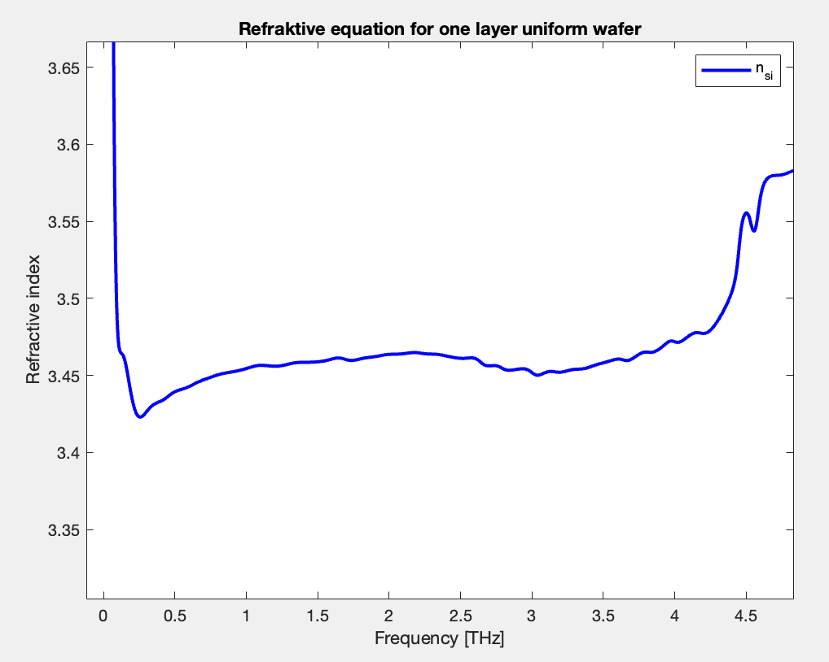

Figure 10: n_ref function
From 4.5THz and forward, we aren’t expecting much. Of different reasons, this isn’t the spectra of choice for these experiments. For everywhere else, it seems as the refractive index of Si can be approximated to be about $n_{Si}≈3,45$. That’s a reasonable approximation of the value. The stability also supports the results. It is possible to extract the refractive index from this equation and datapoints from the setup.
It is possible to try to adjust the refractive index, if it’s affected to much by the singularities happening at $\lim_{ω→0}{n_{si}\left(ω\right)}$. Phase extrapolation is one tool for that.
$n_{si}^{'}\left(ω\right)=n_{si}\left(ω\right)+m·2π\frac{c}{ωd}$ [18]
For m being an arbitrary integer, that ensures, that the best results is seen around $ω=0$.
My approximation of the refractive index was good as it was. Checking for any m around m = 0, did indeed just worsen it.
The estimation of Si is what’s going to be used as the reference, when it comes to deriving the effective refractive index of a thin film
With the refractive index of a uniformly distributed silicon wafer extracted, it was time to progress further towards the thin film approximation. I was given previous data as well as some results of it. Without having derived the expression myself but given from another one, that had previously derived it.
The equation was
$n_{f}=\sqrt{\frac{T·\left(1+n_{ref}-n_{ref}·\frac{j·ω·d}{c}\right)-\left(n_{ref}+1\right)·e^{γ_{ref}·\left(d_{sub}-d_{ref}\right)}}{T·\frac{iωd}{c}}}$
For $T=\frac{E_{sam}}{E_{ref}}$, $γ_{ref}=j·\left(\frac{ω}{d}\right)·n_{ref}$, $n_{ref}$ being the silicon wafer estimate that I calculated for just above, and the dimensions $\left[d, d_{sub}, d_{ref}\right]$ tells the depth of the thin film, the substrate being the minimum height of the remaining wafer after having gone through etching and the depth of the reference wafer before having gone through the process of etching.
The reference was a constant $d_{ref}=523,92μm$ for every type of wafer. The depths of the thin film and depth of the substrate varied from type to type. Having had previous similar types send to a lab for it to destructively measure its dimensions, the depth of the substrate had been found. For the dimensions of the thin film, they were estimated from photos at microscopic levels.
The measurement for the depths was
Types | $d_{f} \left[μm\right]$ | $D_{sam} \left[μm\right]$ | $D_{ref} \left[μm\right]$
${16}_{21}$ | 1.1 | 518.9 | 523.9
${16}_{22}$ | 2 | 519.6 | 523.9
${16}_{23}$ | 6 | 495.8 | 523,9
${16}_{24}$ | 9 | 510.4 | 523.9
${16}_{25}$ | 7 | 496.8 | 523.9
${16}_{26}$ | 5 | 501.2 | 523.9
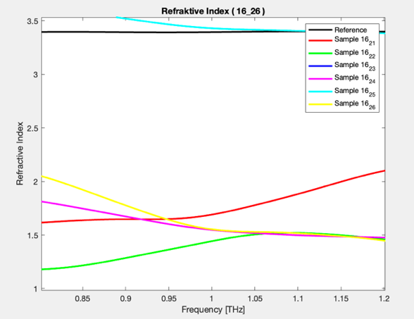
Signal processing
Given that I was trying to recreate findings having been found before, and I had access to the scripts from those I first tried by recreating the results, from the data of mine. The process to create the results, that I was gonna recreate was.
$E\left[n\right]→E\left[n_{0}:n_{0}+190\right]→ \begin{matrix}FFT \\ →\end{matrix} E\left(e^{jω}\right)→E^{⋆}\left(e^{jω}\right)$ For each of the electric field datasets.
$T=\frac{E_{sam}^{⋆}}{E_{ref}^{⋆}}→n_{f}\left(T, n_{ref}, d_{f}, d_{ref}, d_{sam}\right)$
Complex conjugating because matlab follows the engineering convention of a phase shift being negative. Thus going towards the convention of positive phase shifts. The slicing of the array acts as a rectangle window. When using FFT, zeros are padded at the trailing end, just as had it nulled the timepoints afterwards. It does however time shift the samples. Or rather remove a time shift. The data is time shifted at the beginning. With the shift in the rectangular window, we essentially remove some of the shifts. Does it really matter?
$n_{si}≈n_{ref}=1+\left(∠E_{si}-∠E_{air}\right)·\left(\frac{c}{ωd}\right)$
For a time shift of $n_{0}$ using the physics convention of a phase shift:
$e^{jωn_{0}}=e^{jω·n_{0}}$
$n_{si}≈n_{ref}=1+\left(\left(e^{jωn_{0}}+∠E_{si}\left(regular\right)\right)-\left(e^{jωn_{0}}+∠E_{air}\left(regular\right)\right)\right)·\left(\frac{c}{ωd}\right)$
$n_{si}≈n_{ref}=1+\left(∠E_{si}\left(regular\right)-∠E_{air}\left(regular\right)\right)·\left(\frac{c}{ωd}\right)$
So the delay doesn’t matter for a relationship like this. What about for the transfer function?
$∠T=∠\frac{E_{sam}}{E_{ref}}=\left(ϕ_{sam}+e^{jωn_{0}}-ϕ_{ref}-e^{jωn_{0}}\right)=ϕ_{sam}-ϕ_{ref}$
The transfer function is unaffected as well.
Which part of the signal is kept matters though, but what part of signal one is kept in contrast to another might. For the $E_{air}, E_{ref},E_{sam}$ they all had the same $n_{0}$ and the same width of the window.
$E_{air}\left[n_{0}:n_{0}+M\right], E_{ref}\left[n_{0}:n_{0}+M\right], E_{sam}\left[n_{0}:n_{0}+M\right]$
From my dataset by calculations of each signals center point, I’ve calculated
$n_{c}=\left[\begin{matrix}171 & 261 & 256\end{matrix}\right]$
which is the time shifts of the Air, Reference, and Sample datasets, respectively. That’s where we get our refractive index estimates from. If centered at about $n_{cair}$, and by $M=190$ the window of use, the window would be nonzero from: $\left[86;256\right]$. For the case of centering about the center of the air dataset, the center point of the reference signal wouldn’t even have been included.
A signal is mainly about its center, and quickly becomes approximately zero. A choice of center for the window, that got the information that was needed might have been sufficient. But a relationship between different datasets might have been altered.
Using the dataset of the data having made the results, I managed to recreate some of what was shown:
Recreating type ${16}_{22}, {16}_{24}, {16}_{26}$. Some of it were skewed, but as I managed to replicate 3 results. The method of estimating the refractive indices, must have worked.

Data gathering
To differ from the previous findings, I chose to go another direction. Instead of knowing the exact conditions at the place of sampling, would I be able to make profiles on the wafers, knowing previous findings on specs of the wafers. Could I make a rough scan of the entirety of the wafer and make a more general estimation, without too much energy being used to make one thorough dataset. Would the profiles be able to look past harmness done to it from general wear. That was the idea going into the data gathering.
I chose to try to model a gradient image of the wafer. I had 6 types of wafers of a half circle figure. I chose to sample from the tip of it to the center. It was a bit more than 2cm in radius, which gave me [2, 1.5, 1, 0.5, 0] as my sampling interval for each type. Using height adjustment tools, the scanning began just after a time delay appeared on the THz - TDS machine. That would indicate, the first propagation through the wafers
Given this approach, and having heard about etching, a thesis was made, that the time delay of each scan would increase as the amount of scans increased. At etching, the sides of the wafers are more harmed, than the center points, which was the foundation to the thesis.
Figure 11: My setup
Figure 12: The thesis
That’s the idea. Following will be the full datasets to the left and then the data zoomed in on the main transmission of the samples. Data for propagation in air, as well as in the uniform wafer will be graphed as well. The thesis is, that Air having the least amount of resistance for the wave to propagate through will have appear first, the Reference wafer will appear last, having the most amount of resistance for the wave to propagate through and the samples being somewhere inbetween, being somewhat Air somewhat of the Reference wafer.
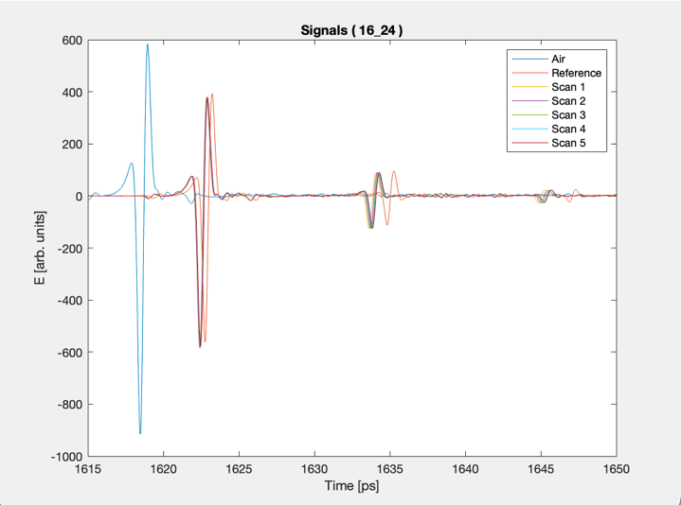
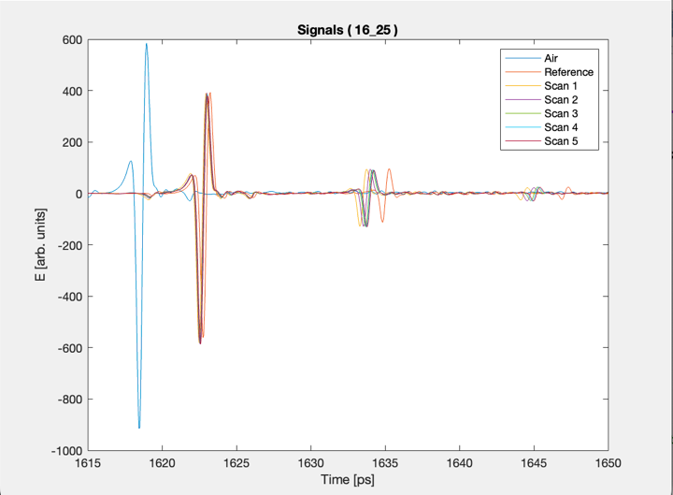
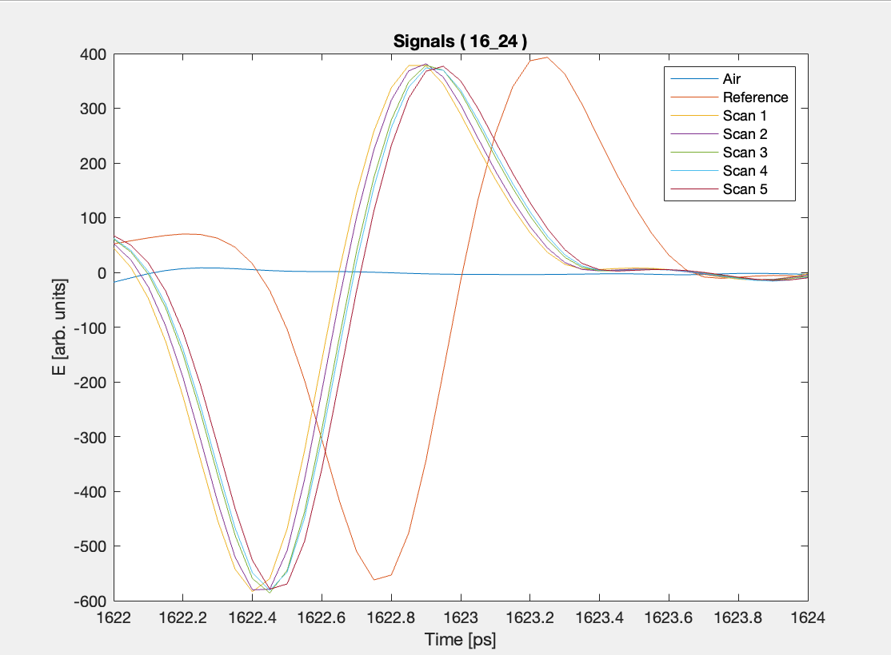
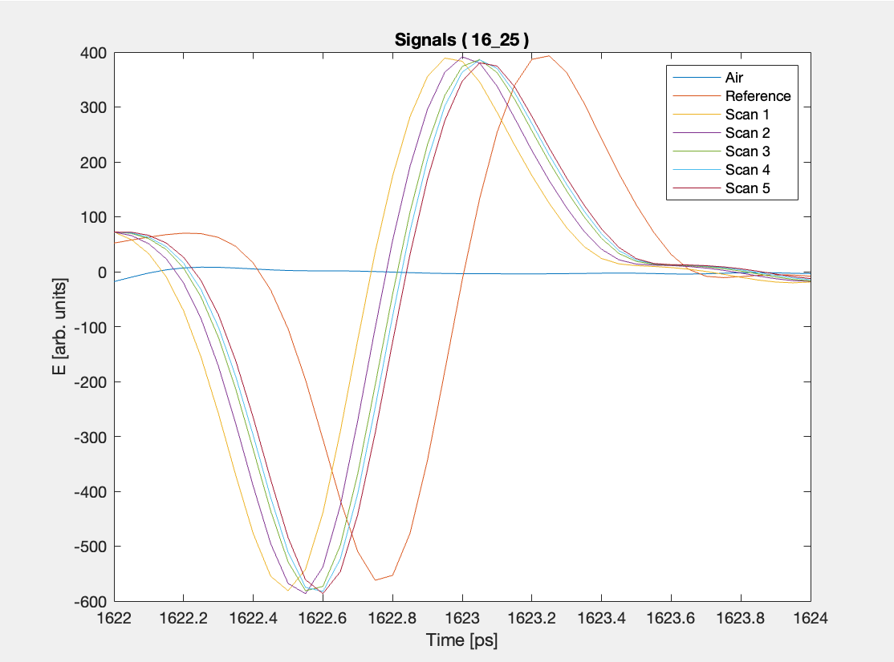
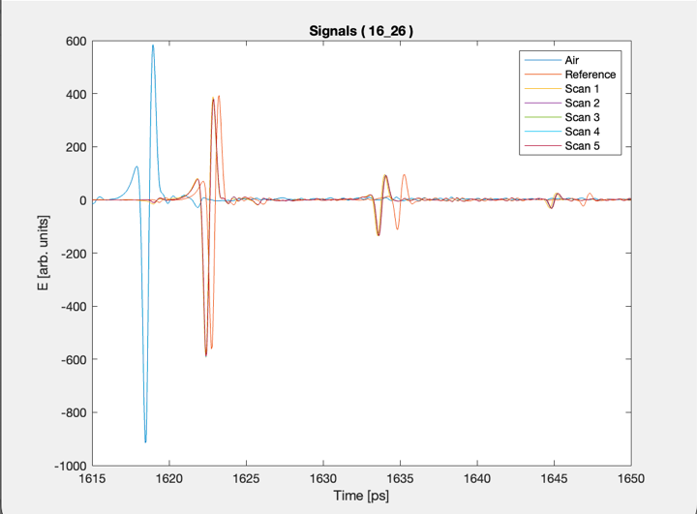
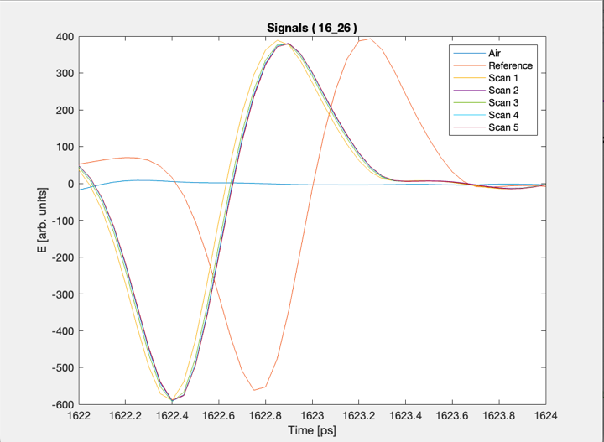

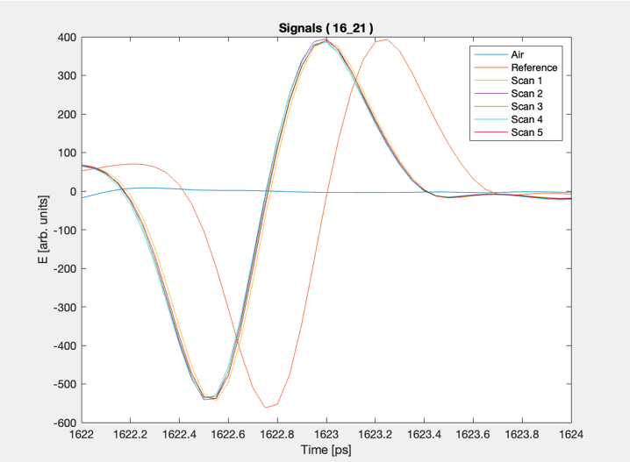
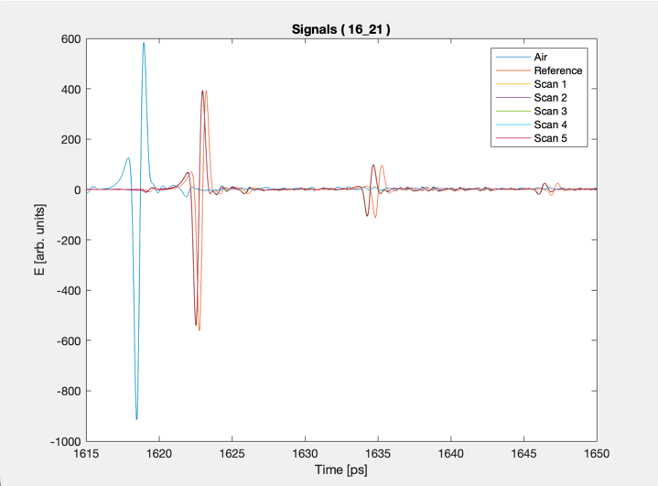
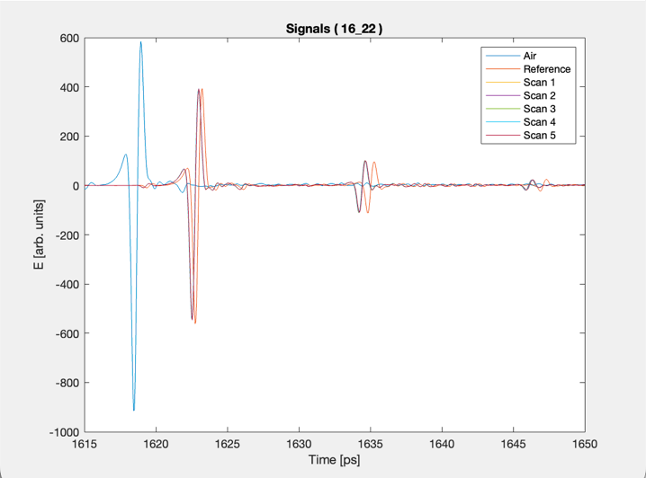
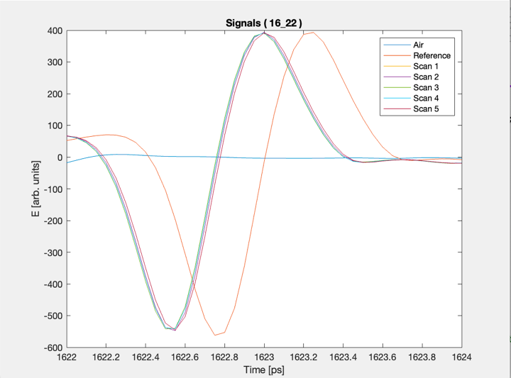
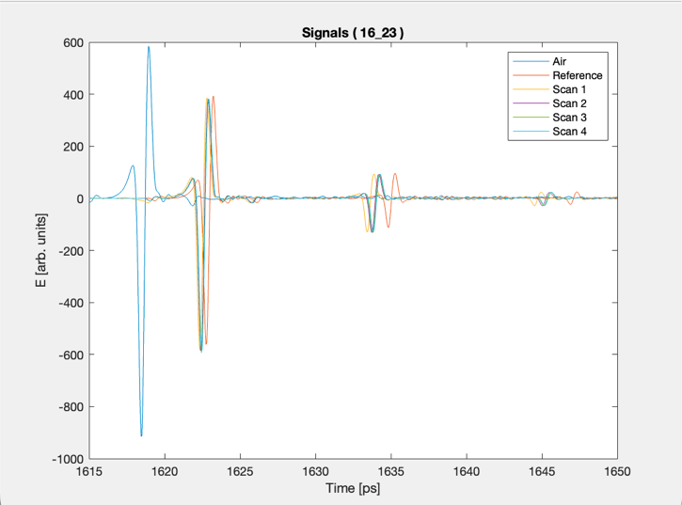
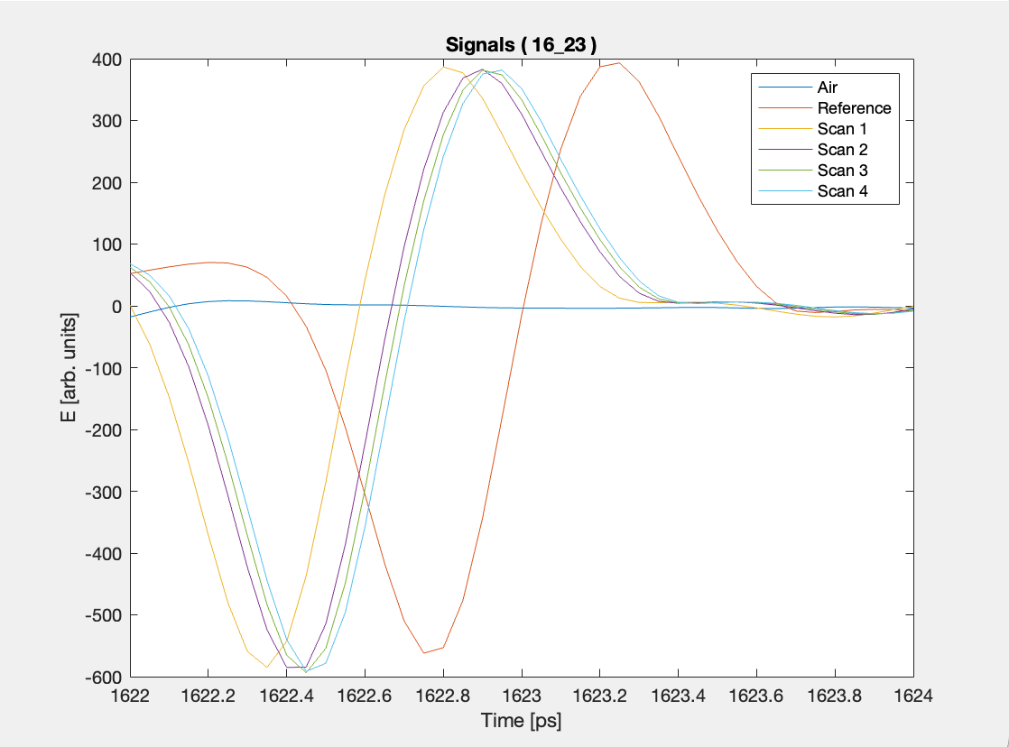
* Things to note from these plots. For type 16_23 I forgot one scan and that’s why there’s only 4 scans. Another note is, it seems that I’ve sampled correctly. Every scan seems to be going towards the reference signal made from the uniform sillicon, except for 16_22 and 16_21, where there doesn’t seem to be that huge of difference, and the minor difference is random. Which is a good thing and just tells us, that the etching had been more effective on those. For all it stands that air having the smallest of refractive index comes first, reference having the highest of refractive index comes last, and the samples somewhere in between, as they are part air, part Si. As one expected.

Removing the reflection by windowing the signal.
Trying to keep the setup as was, when previous results were made, the only thing that needed to be changed, was that my transmission signal was closer to the origin. The previous data had $n_{0}=485$. That relative position, that $n_{0}$ had on that dataset, was the same as $n_{0}=117$ in mine.
Processing my data:
$E\left[n\right]→E\left[117:117+190\right]→ \begin{matrix}FFT \\ →\end{matrix} E\left(e^{jω}\right)→E^{⋆}\left(e^{jω}\right)→n_{ref}\left(e^{jω}\right)$
$T=\frac{E_{sam}^{⋆}}{E_{ref}^{⋆}}→n_{f}\left(T, n_{ref}, d_{f}, d_{ref}, d_{sam}\right)$
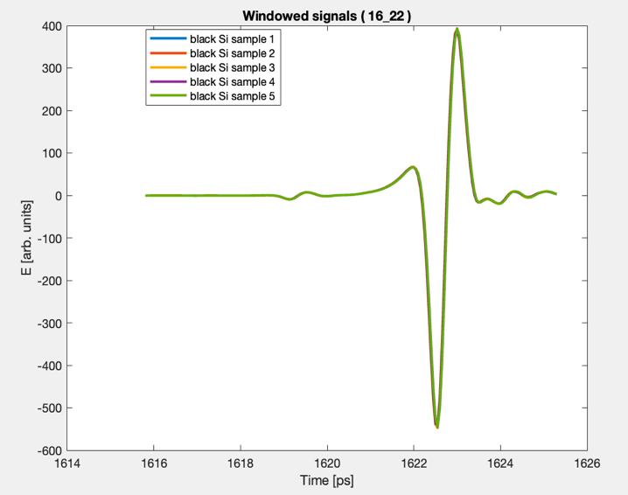
Looking at my windowed signals.
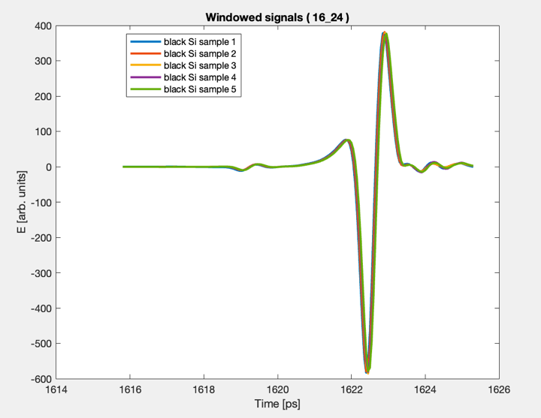
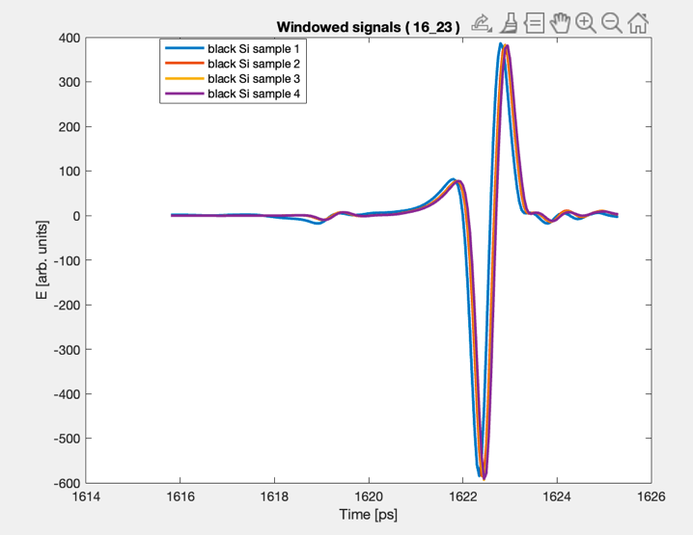
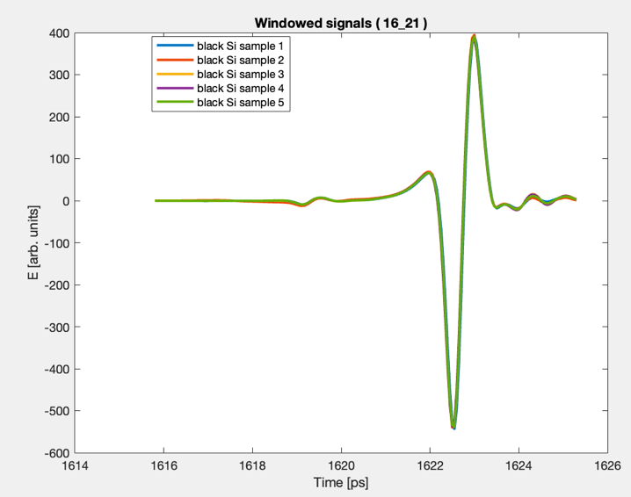

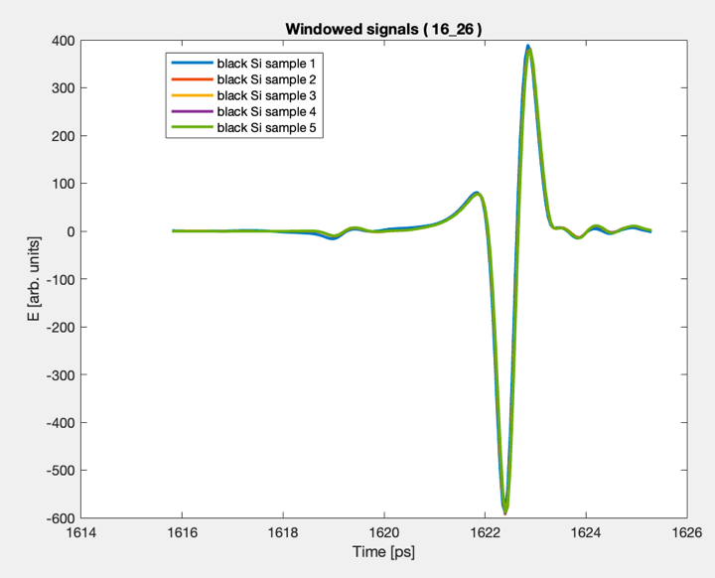
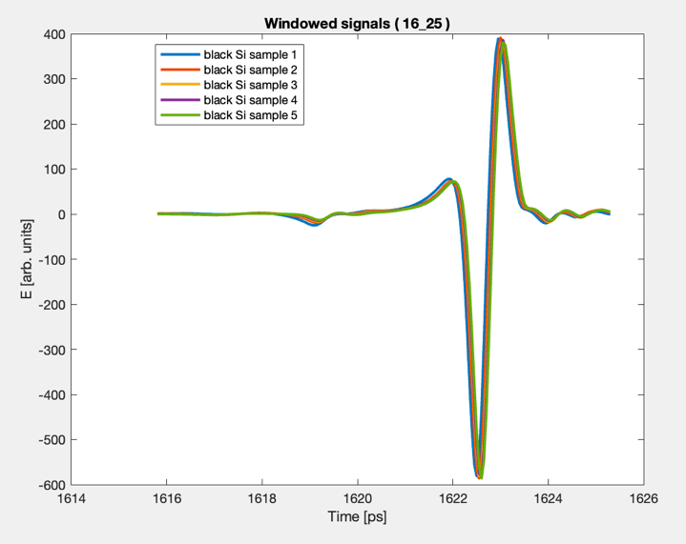
* Note to add to the images. The trailing nulled signal was added later by zero padding at FFT.

Describing my signals in terms of refractive indices of the thin film.
For the equation in my Transmission through a thin film section, an equation of refractive index of a thin film in terms of a reference wafer was derived to be:
$n_{f}=\sqrt{\frac{T·\left(1+n_{ref}-n_{ref}·\frac{j·ω·d}{c}\right)-\left(n_{ref}+1\right)·e^{γ_{ref}·\left(d_{sub}-d_{ref}\right)}}{T·\frac{iωd}{c}}}$
Where $n_{ref}$ was the calculated refractive index of the reference wafer as a function of frequency. $d, d_{sub}, d_{ref}$ being depths of the layer of the thin film, the substrate and the reference, respectively. $ω$ being the angular frequency and $c$ being the speed of light. $γ_{ref}$ is the propagation constant and can be described as $γ_{ref}=j·\frac{ω}{c}·n_{ref}$.
This was the equation used for the other results, and one I used for most of my experimentation.
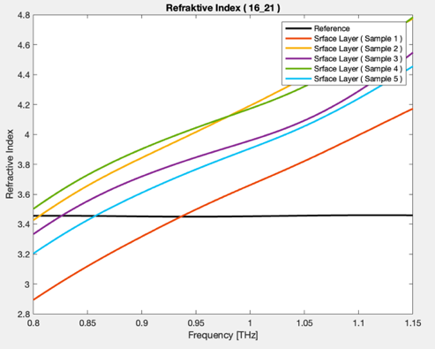
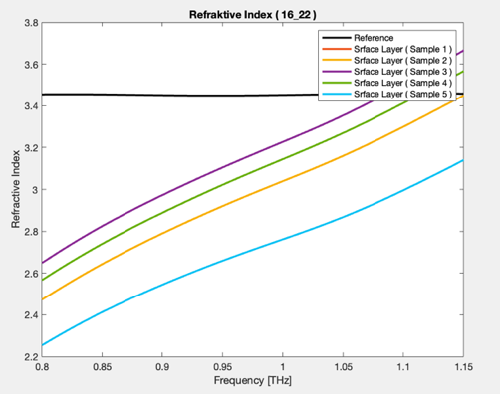
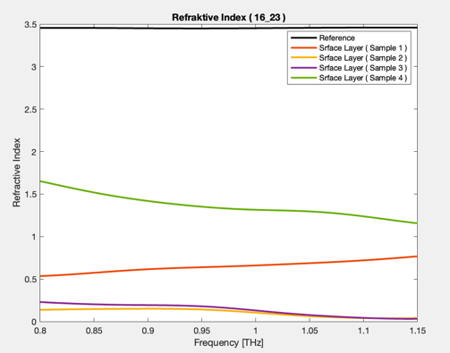
The results of my data:

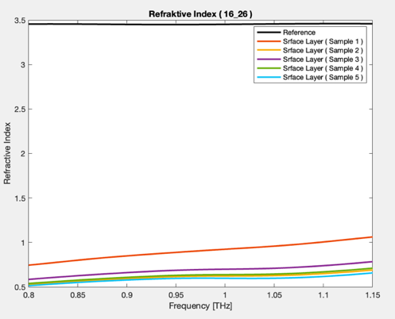
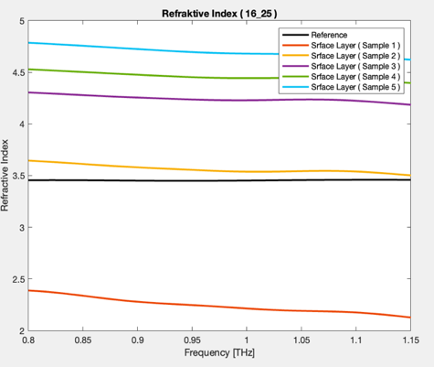
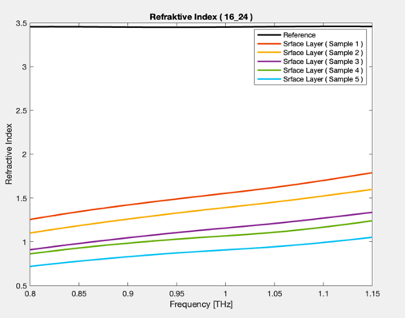
Noting that the black bar is the $n_{ref}$ function. It’s clear to see, that the equation isn’t well functioning with my data. The indices are bound to be within $n_{f}∈\left[1, n_{si}\right]$ for them physically true.
As the black bare is the upper boundary, a lot of them surpasses the physical max value. Not only were some higher than the maximum physical value, some were below the physical minimum value as well. Something wasn’t right, and having gone back and forth in the setup a handful of times. Other approaches were tried.
Would a gaussian distribution make a better profile? With 5 datasets for each type. More would have been preferred but might make an okay gaussian distribution.
Or as a 95% confidence interval normal distribution going from opaque to transparent: $\hat{x}±2\hat{σ}$. 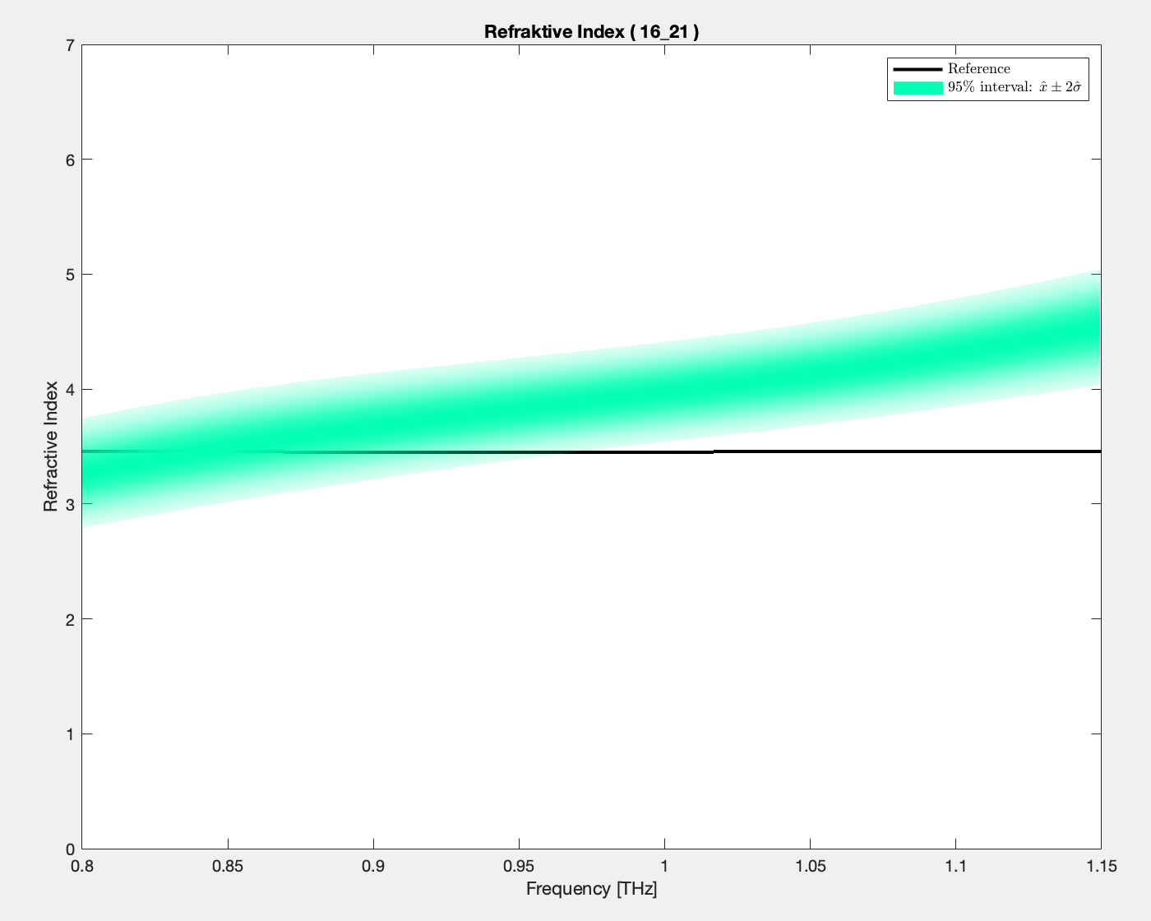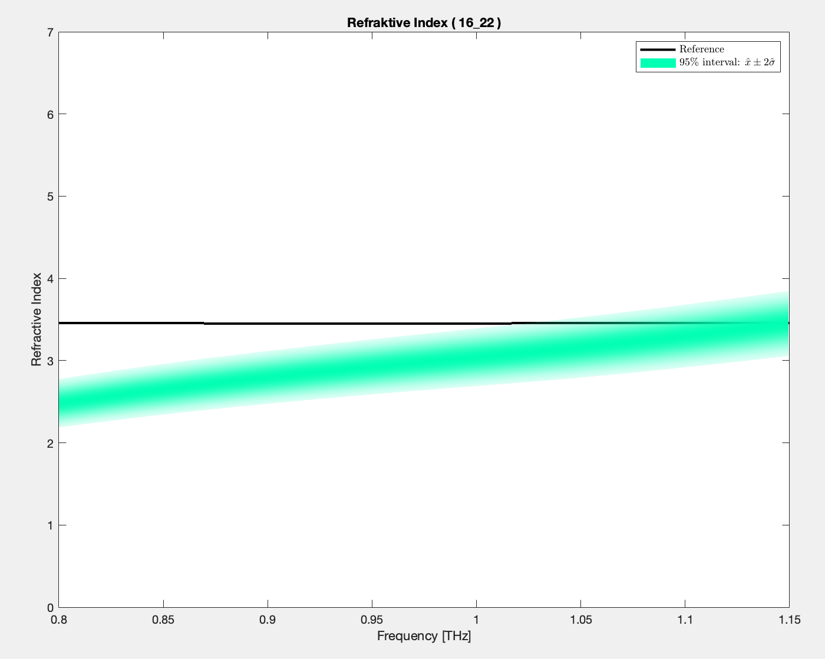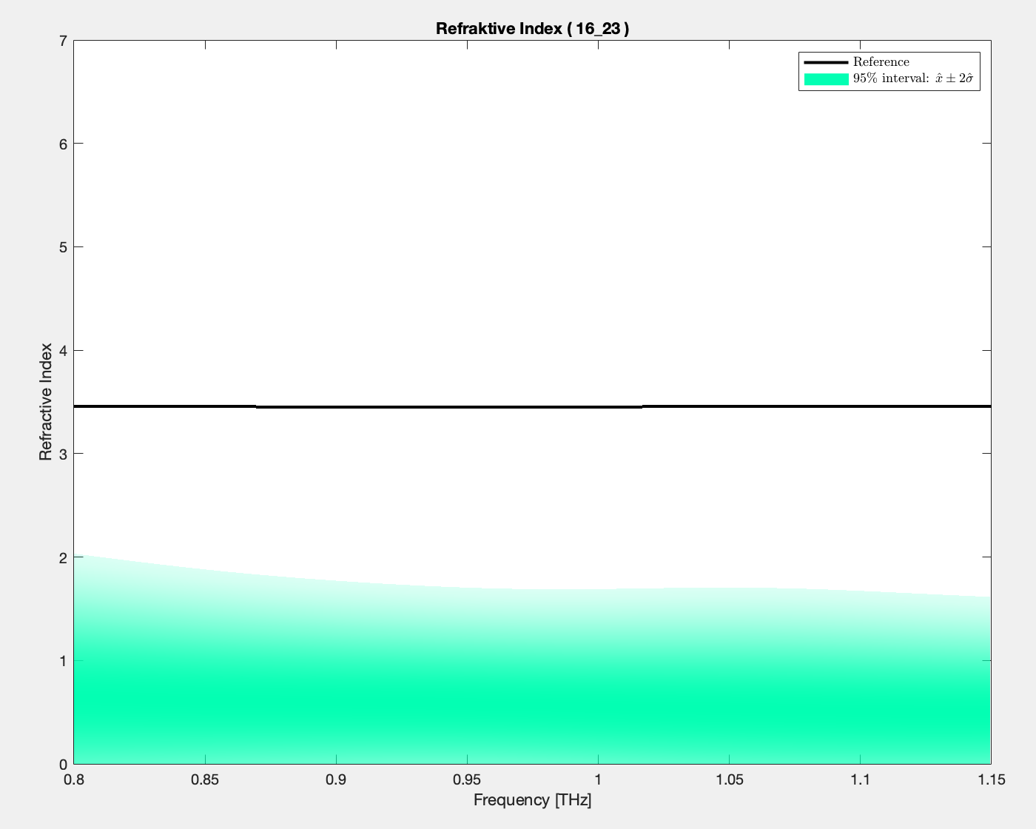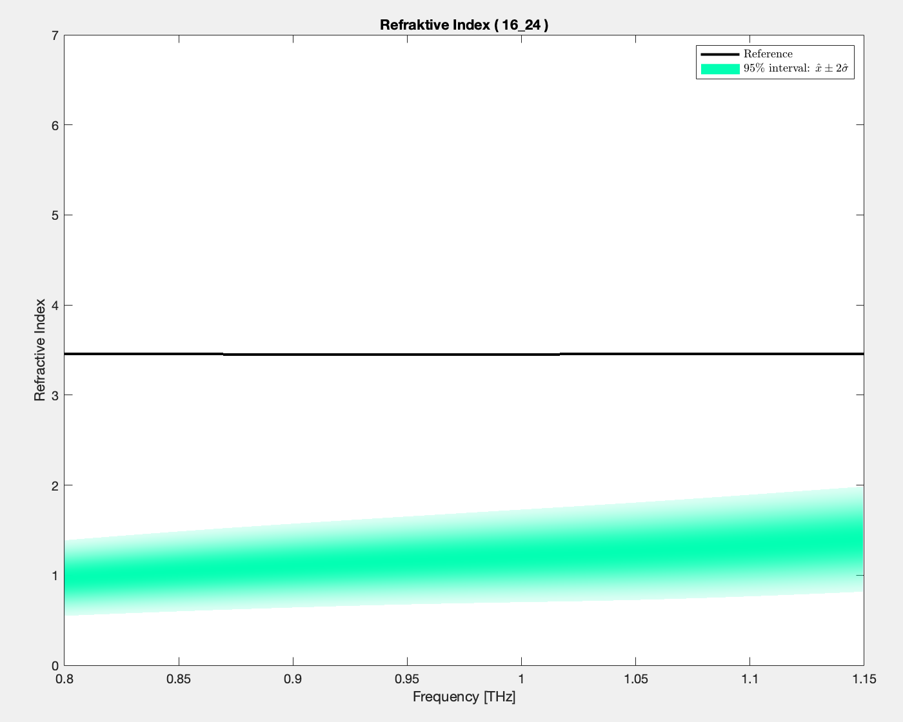
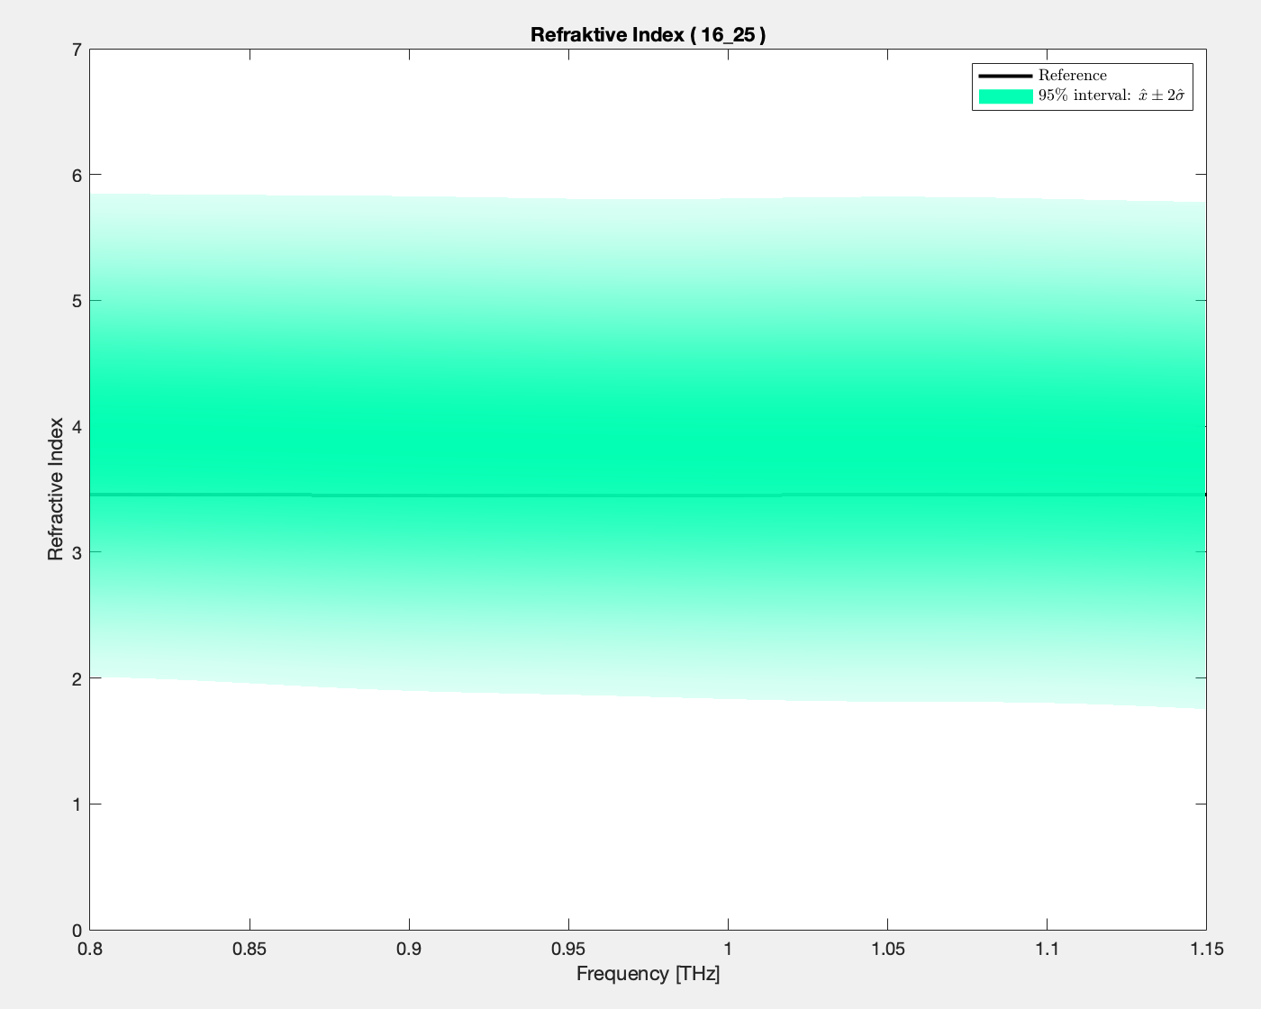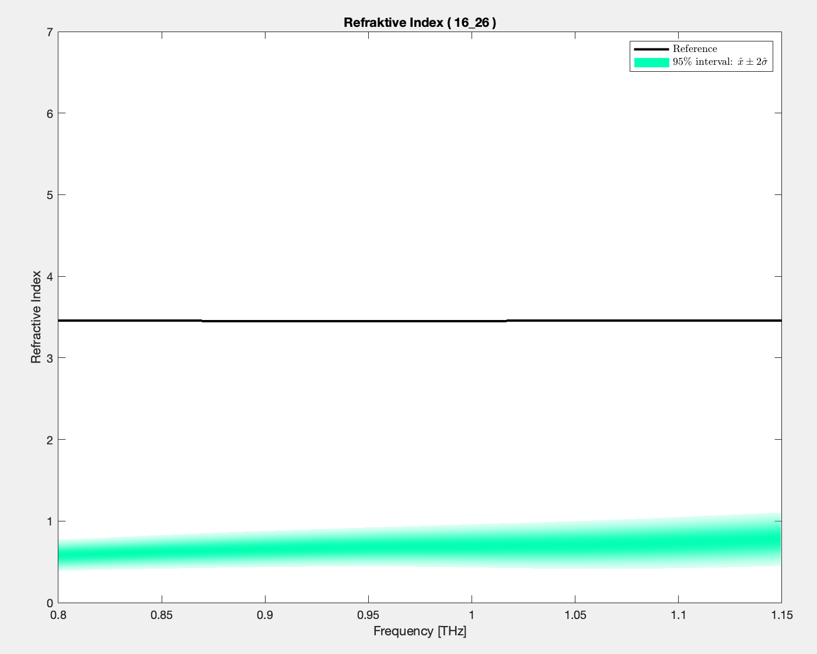Doesn’t really tell me that much either. They are hard to differentiate from each other. And the issue of them isn’t solved.

We’ve derived our equations from measurements of other wafers and expecting them to be similar.

Uncertainty.
The thing is, that the wafers are said to be $±20μm$. $20μm$ is a lot in these context, where the biggest difference in my reference vs etched material is about $25μm$. Trying to adjust the values of the dimensions, some of the results that had previously not been proven, was shown, or close to atleast. Having trying to edit the setup back and forth, I wanted to look at the effect of these uncertainties.
Within the equation for the thin film, $d$, $d_{ref}, d_{sam}$ contributed multiple times. I tried deriving and expression for the min, max values of the refractive index, at first, but that showed to be difficult. Instead I choose to brute force a 5D matrix varying for the $d, d_{ref}, d_{sam}, scans, types$.
Having set the amount of variations to K = 5, my matrix was of size
$n_{f}\left(d, d_{ref}, d_{sam}, m, l\right)∈R^{K×K×K×M×L}=R^{5×5×5×5×6}$
The reference had an uncertainty of $±20μm$. I assummed that transferred directly to the substrate as well. Could be a wrong assumption, but was what I went with.
$\left(d_{ref}, d_{sam}\right)±20μm$
The thin film depths were derived from pixels on an image. An educated uncertainty was said to be
$d±0,5μm$
Making a linspace from min -> max value of each dimension, for K amount of points. My matrix was created.

Min / maxing the dimensions
$$n_{f}∈k_{d_{ref}}, k_{d_{sam}}, k_{d_{film}}, m_{samples}, l_{types}$$For having calculated for every variation, the following plots shows the max and min values, given certain combinations.
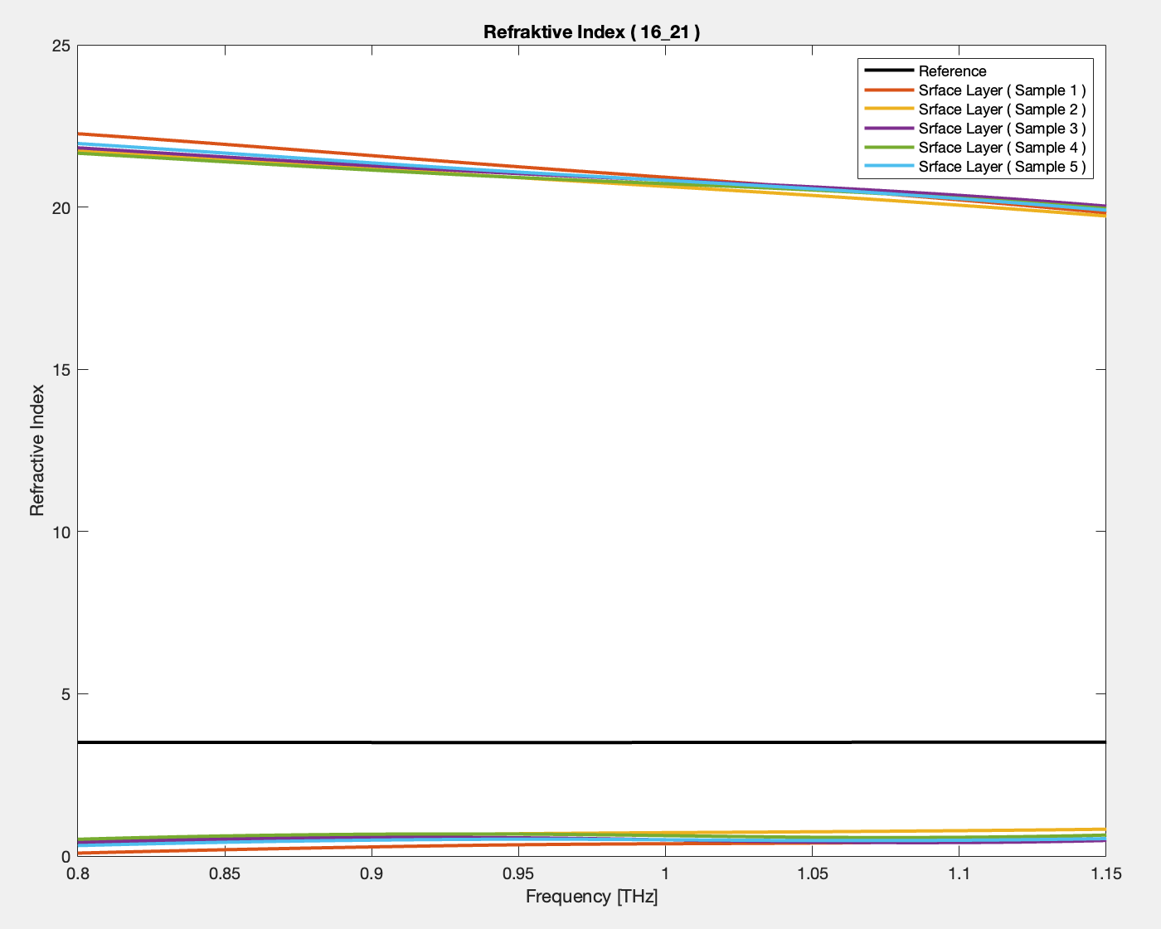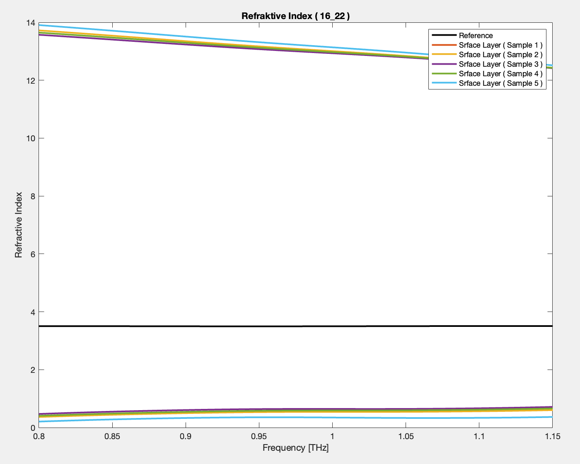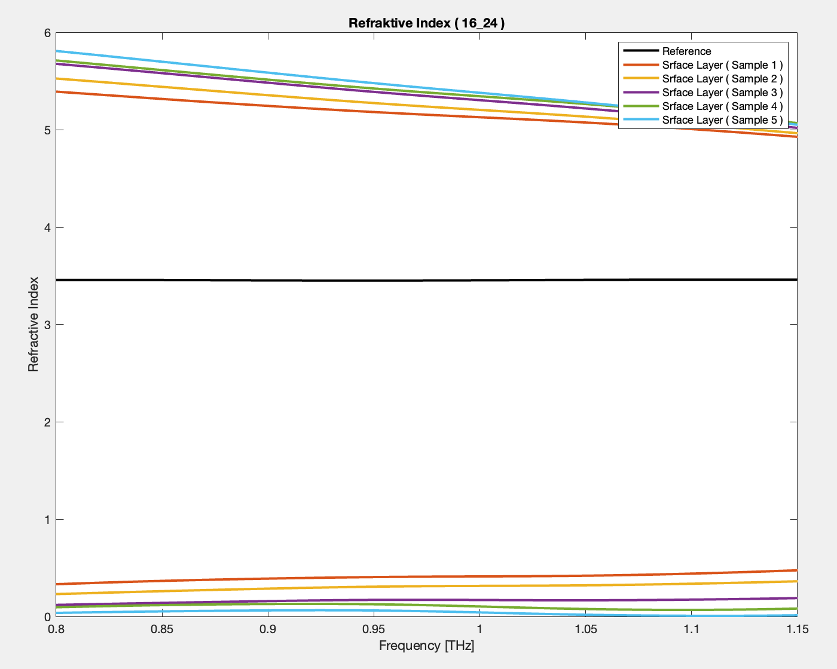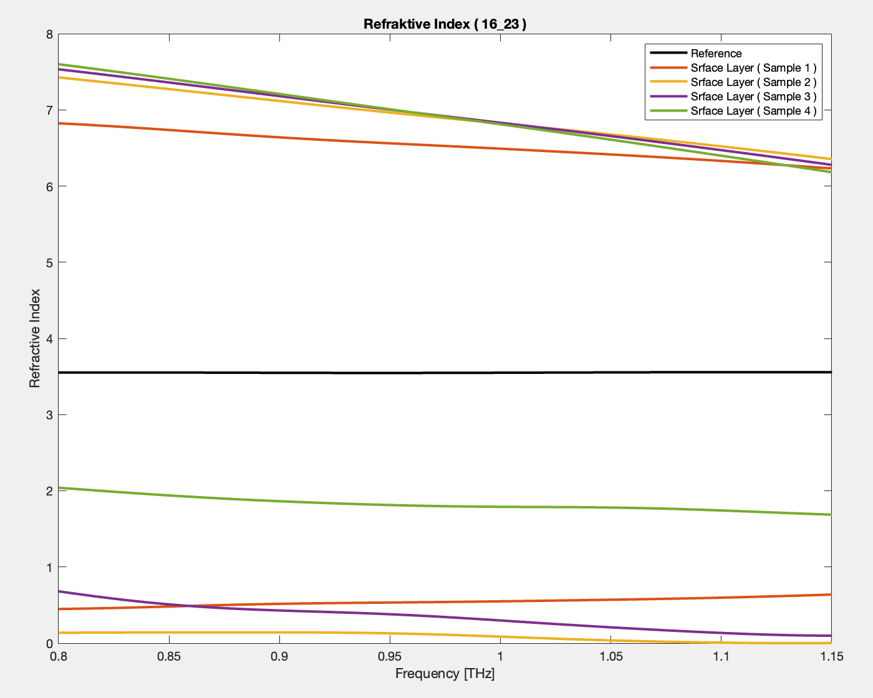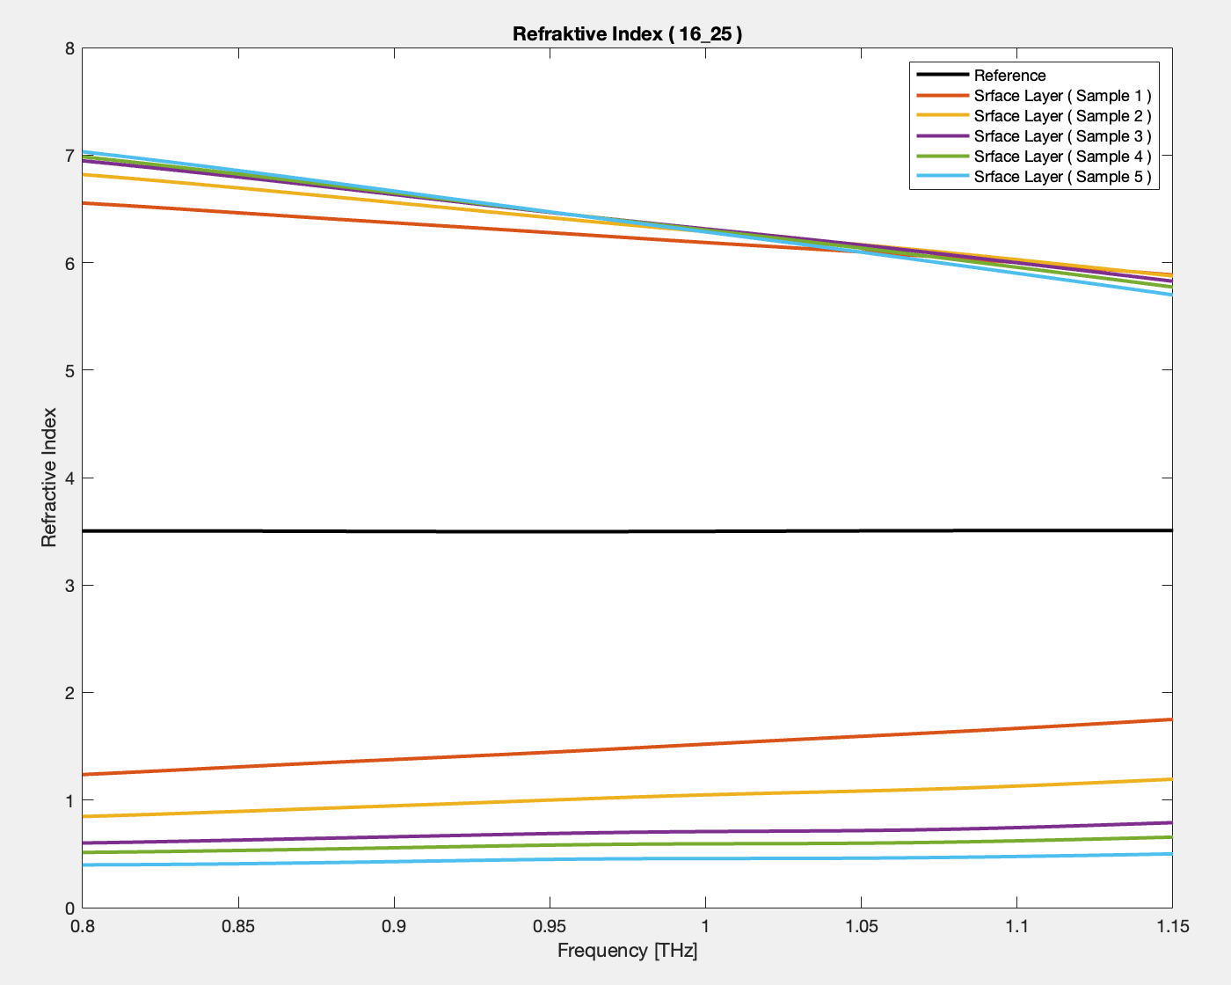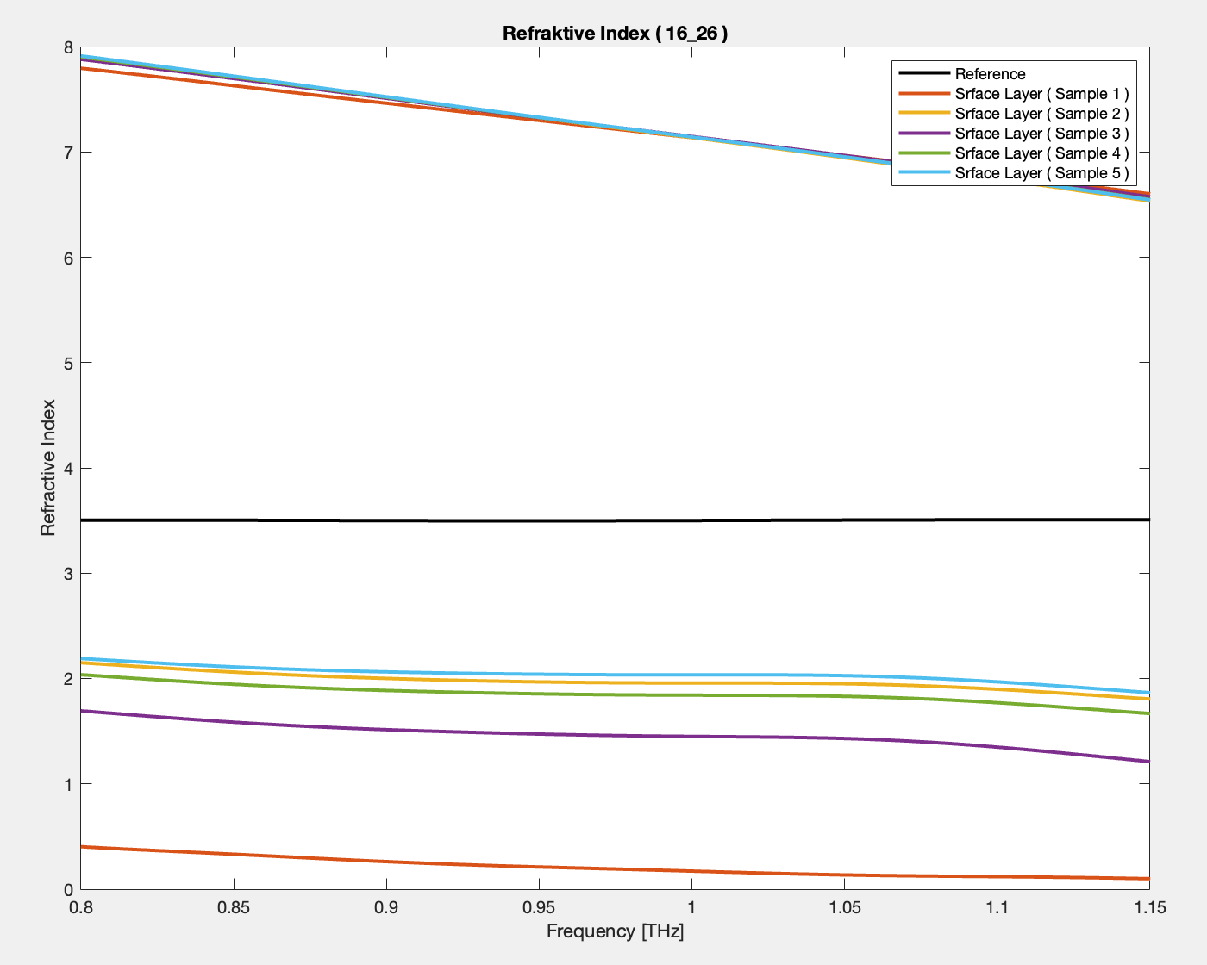
Type | $\hat{μ}$ | $\hat{σ}$
1 | 8,15 | 5,34
2 | 5,83 | 3,63
3 | 3,20 | 2,31
4 | 2,51 | 2,18
5 | 3,54 | 2,18
6 | 3,22 | 2,22
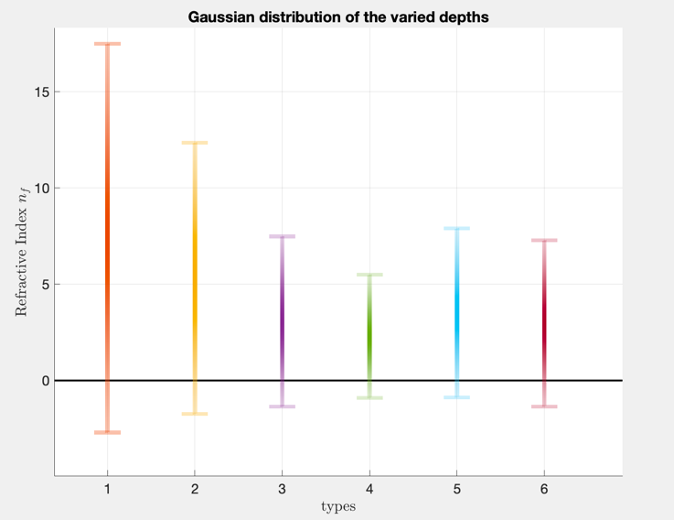
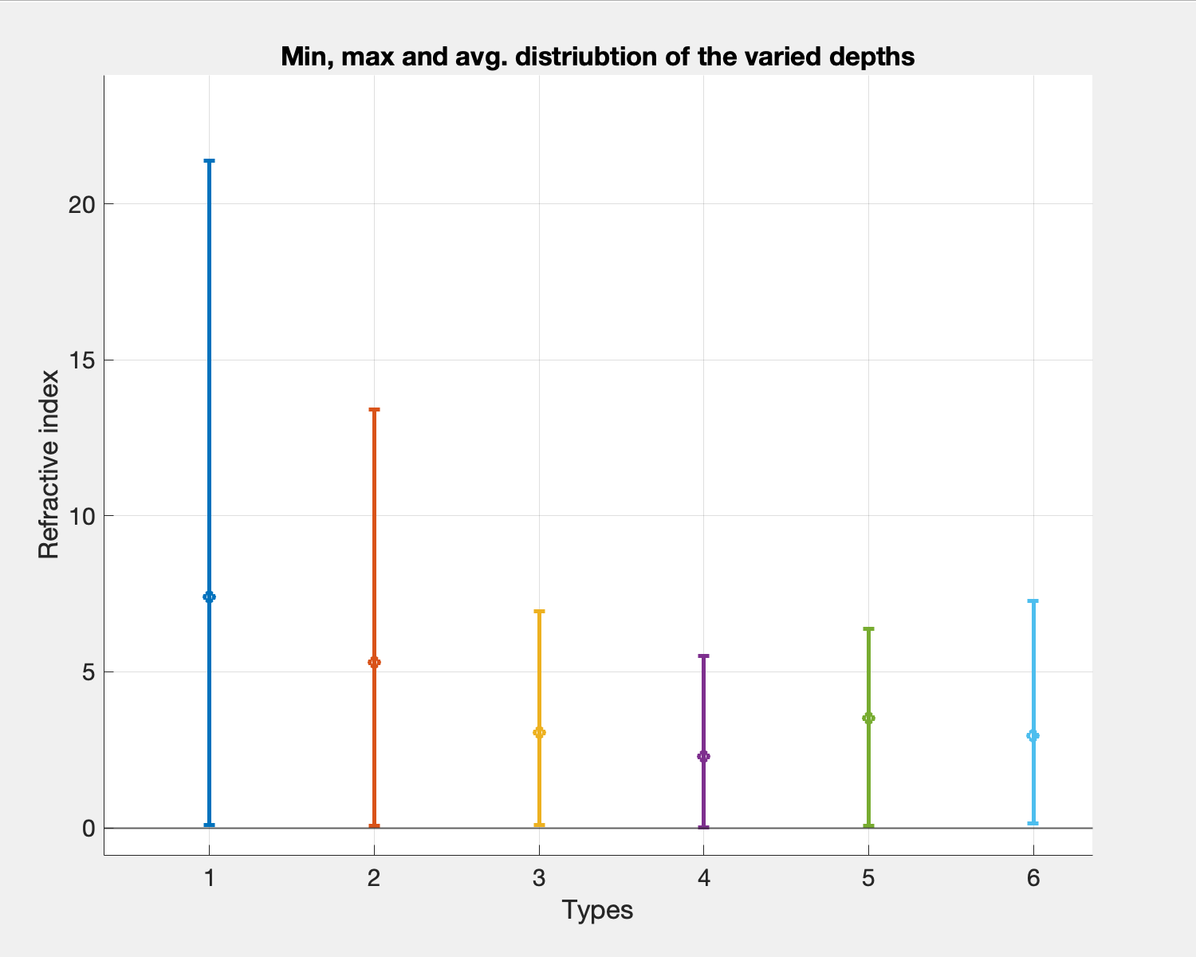
But can also be expressed in other ways:
In terms of min/max values and an average. This doesn’t highlight the insignificant likelihood of the outliers. The gaussian distribution has it all weighted in a gaussian distribution, showing a 95% interval. Outliers may then not even be considered within the distribution, as seen for the outlier / outliers of type 1.
Something is still wrong with our assumptions, as the centers of these gaussian distributions are still very high.
Figure 13: Thin film refractive distributions. Left showing the min-> max value with the mean dotted. Right shows the gaussian distribution for each type given the variation in dimension. Its alpha is supposed to illustrate the probability. The more transparent, the more insignificant is the opportunity of receiving a refractive index of that value
Figure 14: Mean and standard deviation due to variations

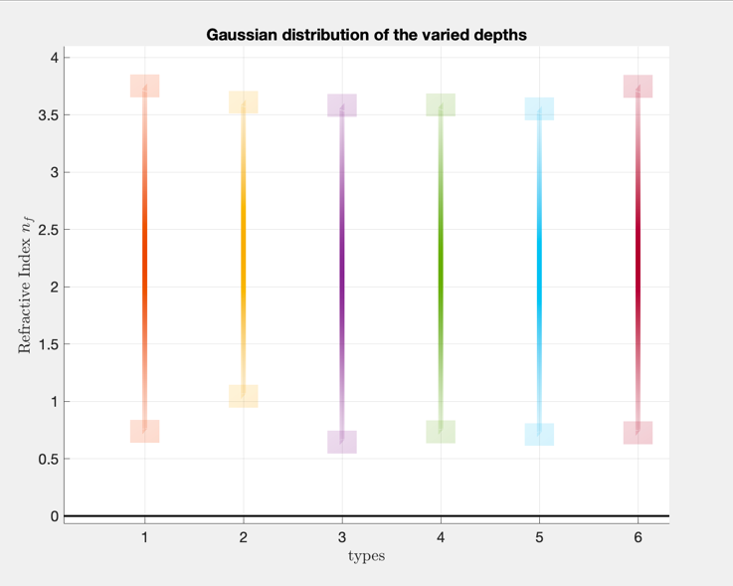
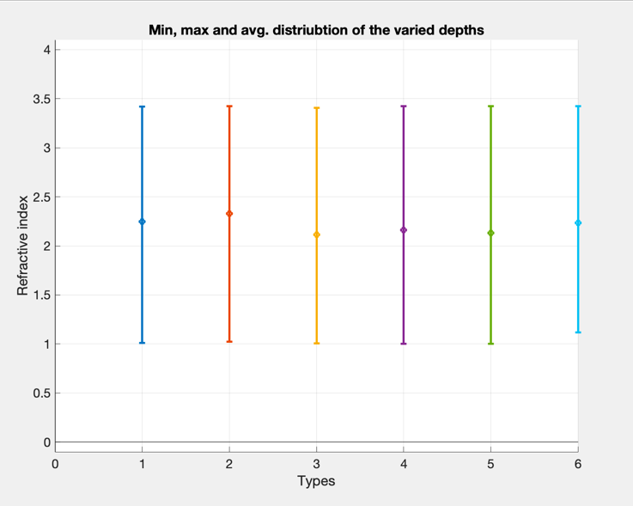
What if only the physical possible values were used? I did try that too.
Figure 15: Min, max and avg. distribution compared with the gaussian distribution. Both made solely on the calculations that didn't lead to unphysical values.

New setup
After having given the replicated setup a fair chance, I wanted to try out new paths. The spectra was chosen due to stability at these ranges for that dataset. It might not be the most optimal for the dataset of mine.
Also the tukey window makes for a more fluent transition from our signal towards 0. For the rect, discontinuties which might introduce higher frequency components. Ideally I would want to use the tukey window, so this time, I will.
I window of size 400 was chosen.
Each transmission is shifted 12ps/0,05ps = 240 timepoints. However the second transmission line is with significantly lower amplitude. The benefit of keeping most of my transmission signal overcame the cost of letting the second transmission signal interfere. The center of the window was also aligned for every signal to ensure, that the same parts were compared, and thus that only the phase due to propagation was left.
And one and final thing, that was noticed at deriving was, that the propagation in air was never accounted for in the sample beam. In my effect of propagation in air, I commented on the deriving of the transmission function assuming that the phase due to propagation in the air, for the etching having etched the whole surface of the wafer down an equal amount. It would be interesting to use the function on my dataset to check for better results.
$$n_{f}=\sqrt{\frac{c}{j·ω·d_{f}}·\left(n_{ref}+1\right)·\left(1-\frac{P_{air}}{T}\right)-n_{ref}}$$Is equivalent to the equation we used before, but in a different form. Each array is referred to fewer amount of times, which may lead to less computational errors.
What the phase in air changed wasn’t the form, but it was the phaser in the $P_{air}$.
$P_{air}=e^{j·\frac{ω}{c}·n_{ref}·\left(-d_{ref}+d_{sub}\right)}→$ $e^{j·\frac{ω}{c}·\left(n_{ref}-1\right)·\left(-d_{ref}+d_{sub}\right)}e^{j·\frac{ω}{c}·d_{f}}$

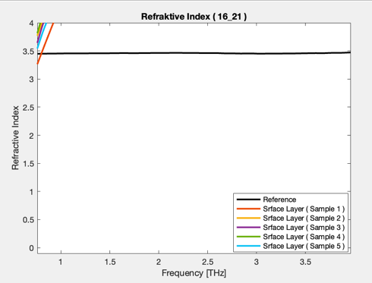
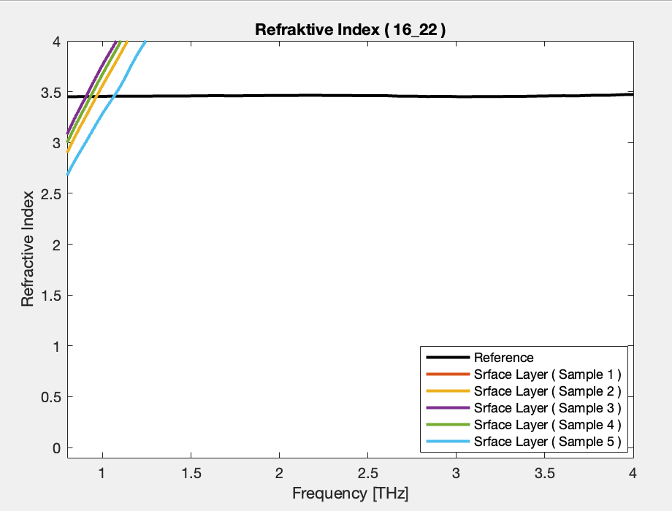
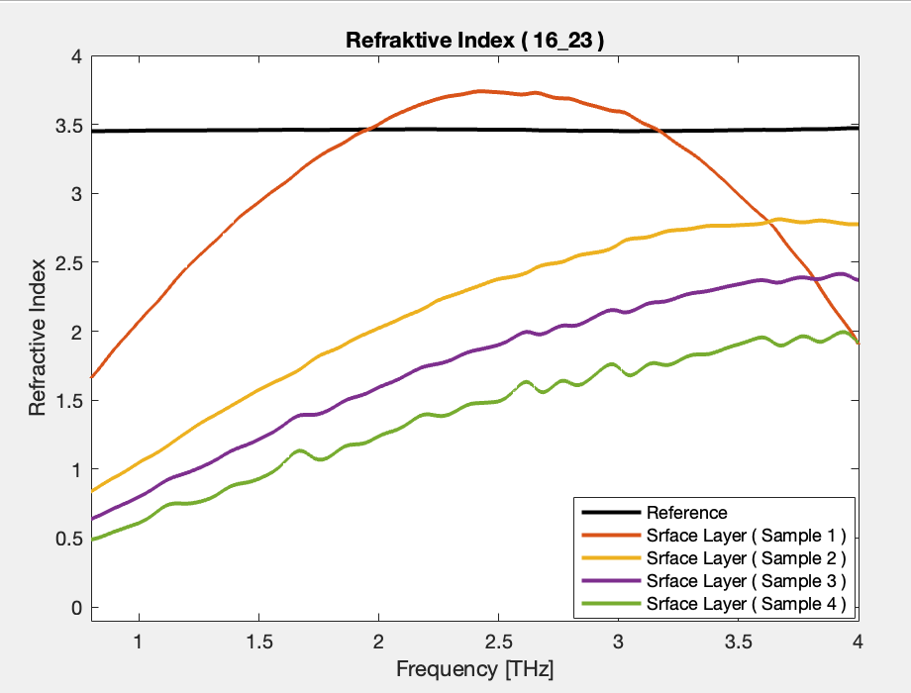
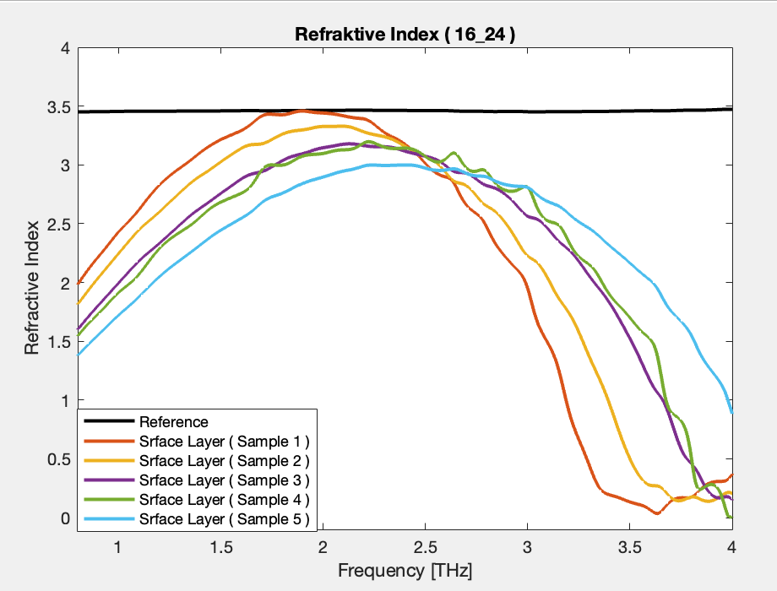
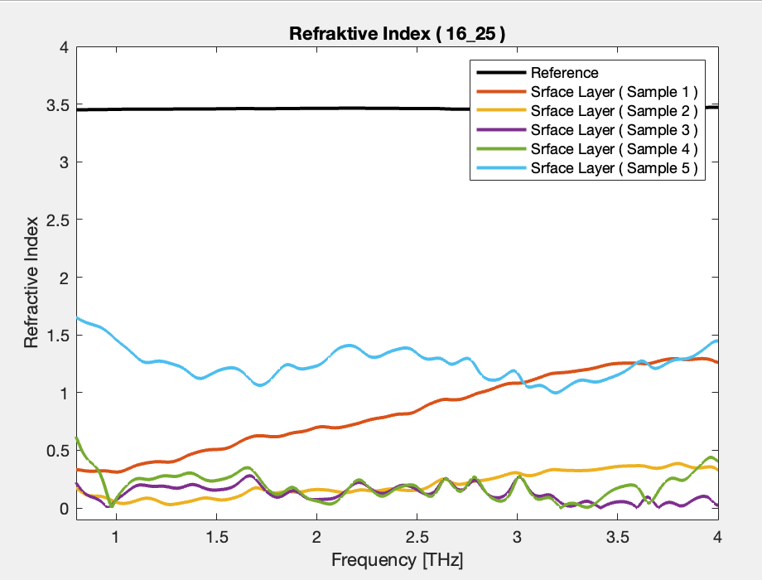
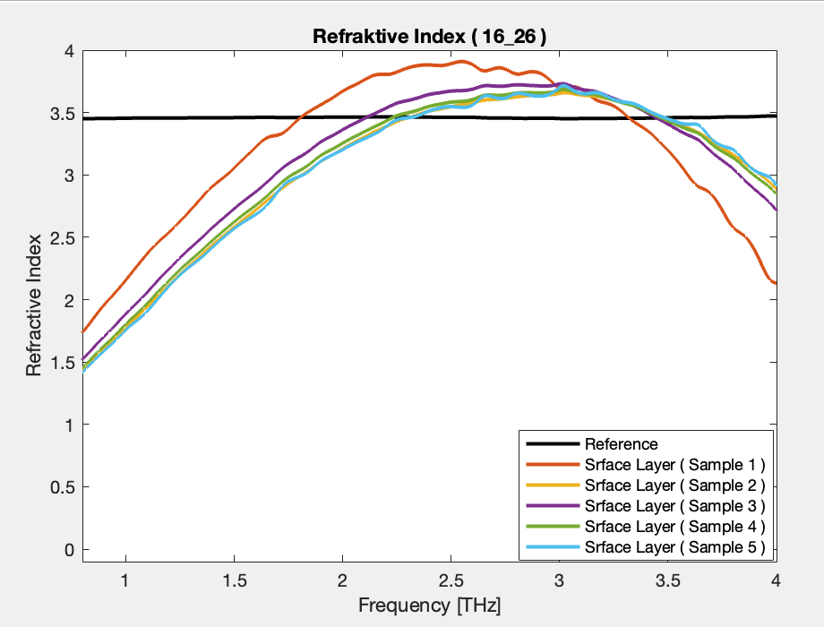
Figure 16: Thin film refractive indices after having set it up by tukey windows, and alligned to each of the signal. Type 16_22, 16_21 and 16_25 have unphysical values along the whole spectra.
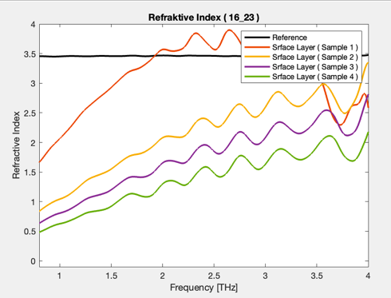
Compared it to $↕$.

Which was the old spectra of ${16}_{23}$, one clearly sees that the new window has reduced the oscilation by a lot. The main problem of the refractive index still being unphysical percists.
One note to take in mind however is, that it seems that my spectra has a much better stability around the $\left[1.5, 3\right]THz$.

Discussion
Having worked with the different parts of what’s THz-TDS, a lot of issues have been solved that one doesn’t necessarily know. Alternating the THz signal for moving the signal to higher frequencies, for then to be able to modulate them back to DC frequencies, were an intelligent and smart solution, that one wouldn’t have known of why that was used, before one looked up the problems of noise. A lot of clever solutions have already been thought off out there, and its only when one starts to ponder why the solution was needed in the first place, that one truly gets the solution.
I thought that my new more including refractive index of the thin film, would have been what was needed for my dataset to estimate the thin film with wonders. Credit where credits is due, it looks a lot smoother, than previous, but still has values outside of what’s physically possible. I’ve tried to ponder about a solution, but I might not look for the right problems. A lot of time was spent trying to verify my dataset to some results, that hadn’t been exposed to the exact same condition as for mine. Were the deviations due to insufficient precision of measures?
Opposite to high precision is approximations, and those were made for the propagation of light.
In an ideal scenario, no energy will be lost to the materials of propagating through, but I know from optics, that everything might not work as linearly as one would have hoped. Were our approximation of no attenuation at propagation too simplified? Have it affected the end result, and if yes, by how much?
What brings an expression in terms of the effective thin film media, is the assumption, that it would have contributed with small angles. And with some films being about 10 times larger than the smaller once, wouldn’t a transformation like that not drive our samples further apart from one another?
Also, the assumptions that just outside of the center of the second transmission, the signals contribution to the first transmission would be negligible. Or is there something that I’m missing?
And can we truly expect the wafers to be as we think or have then worn down over time? Scratching little by little. It is never ones intention to wear it down, but mishaps happen.
As told, I’m only really able to wonder why, when I’ve convinced myself on how.

Conclusions
This project investigated whether repeated rapid THz-TDS scans can be used to estimate a representative refractive-index profile of a thin film.
The analysis revealed several sources of uncertainty, making the extraction of a general refractive index profile less straightforward than initially anticipated. A general refractive profile being the whole point about it.
These uncertainties resulting in high variations of the estimations on the thin film refractive index, and a lot even being unphysical.
The equation of estimation used for previous findings were an okay approximation but were missing propagation in air due to an overall etching of the wafer. It seemed to stabilize my estimations further.

Bibliografi

[1] | C. A. S. Jens Neu, »I. Introduction,« Tutorial: An introduction to terahertz time domain spectroscopy (THz-TDS), p. 1, 9 July 2018.
[2] | C. A. S. Jens Neu, »B. THz generation from a PCA,« Tutorial: An introduction to terahertz time domain spectroscopy (THz-TDS), pp. Side 3-4, 17 December 2018.
[3] | C. A. S. Jens Neu, »IV. THz DETECTION,« Tutorial: An introduction to terahertz time domain spectroscopy (THz-TDS), pp. 4-5, 9 July 2018.
[4] | C. A. S. Jens Neu, »B. THz detection with PCAs,« Tutorial: An introduction to terahertz time domain spectroscopy (THz-TDS), p. Side 5, 17 December 2018.
[5] | C. A. S. Jens Neu, »II. CONCEPT OF TIME-DOMAIN SPECTROSCOPY (TDS),« Tutorial: An introduction to terahertz time domain spectroscopy ( THz - TDS ), p. Page 2, 17 December 2018.
[6] | C. A. S. Jens Neu, »B. Potential noise sources,« Tutorial: An introduction to terahertz time domain spectroscopy (THz-TDS), pp. 7-8, 17 December 2018.
[7] | C. A. S. Jens Neu, »C. Time constant, scan speed, and scan length,« Tutorial: An introduction to terahertz time domain spectroscopy (THz-TDS), p. 7, 17 December 2018.
[8] | C. A. S. Jens Neu, »C. Lock-in detection,« Tutorial: An introduction to terahertz time domain spectroscopy (THz-TDS), p. 5, 17 December 2018.
[9] | B. M. N. ("Electromagnetic Waves" in the appendix ), »NORMAL INCIDENCE ON A PENETRABLE PLANAR INTERFACE,« Electromagnetics, pp. 483-485, 2010.
[10] | Wikipedia, »Definition«.Propagation constant.
[11] | Wikipedia, »Plane wave«.Propagation constant.
[12] | Wikipedia, »Wave model«.Electromagnetic Radiation.
[13] | Wikipedia, »Propagation speed«.Electromagnetic radiation.
[14] | Wikipedia, »Wave impedance«.Refractive index.
[15] | A. V. O. A. S. W. S. H. N. ("Discrete time Fourier transform properties" in the appendix), »TABLE 5.1 PROPERTIES OF THE DISCRETE-TIME FOURIER TRANSFORM,« Signals and Systems, 2nd edition, p. 391, 1996.
[16] | A. V. O. A. S. W. S. H. N. ("Discrete time Fourier transform table" in the appendix ), »TABLE 5.2 BASIC DISCRETE-TIME FOURIER TRANSFORM PAIRS,« Signals and Systems, 2nd edition, p. 392, 1996.
[17] | Wikipedia, »Tukey window«.Window function.
[18] | P. U. Jepsen, »2 THz-TDS Phase Retrieval,« Phase Retrieval in Terahertz Time-Domain Measurements: A "how to" Tutorial, pp. 400-401, 27 Marts 2019.
[19] | L. Madsen, »3.2 Refractive index by phase shift,« Terahertz Time Domain Spectroscopy for characterizing thin films, 3 June 2001.
[20] | C. A. S. Jens Neu, »I. INTRODUCTION,« Tutorial: An introduction to terahertz time domain spectroscopy (THz-TDS), p. 1.
[21] | »II. Concept of Time domain spectroscopy ( TDS )«.
[22] | L. Madsen, »5.2 Substrate thickness variation,« Terahertz Time-Domain Spectroscopy for characterizing thin films, pp. 54-55, 3 June 2021.
[23] | Wikipedia, »Error of the approximations«.Small-Angle approximation.
[24] | Wikipedia, »Relation to the complex exponential function«.List of trigonometric identities.
[25] | Wikipedia, »Power-reduction formula«.List of trigonometric identities.
[26] | A. V. O. A. S. W. S. H. N. ("Continuous time Fourier transform..." in the appendix), »4.6 Tables of Fourier properties and basic Fourier transform pairs,« Signals & Systems, 2nd edition, pp. 329 - 330, 1996.
[27] | D. M. Vinay K. Ingle, »Design of FIR filters by windowing,« Applied Digital Signal Processing, p. 561, 30 September 2011.

Appendix

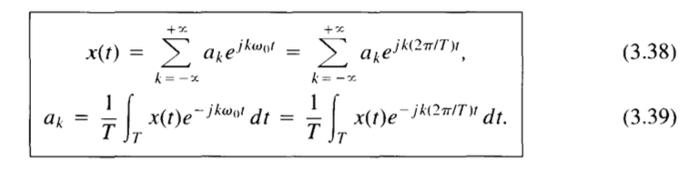
Fourier series representation.

Figure 17: The fourier series coefficients equation as well as how to reconstruct a signal from coefficients. Taken from the book by Alan V. Oppenheim, Alan S. Willsky, S.Hamid Nawab called Signals And Systems 2nd edition

Continuous time Fourier transform properties
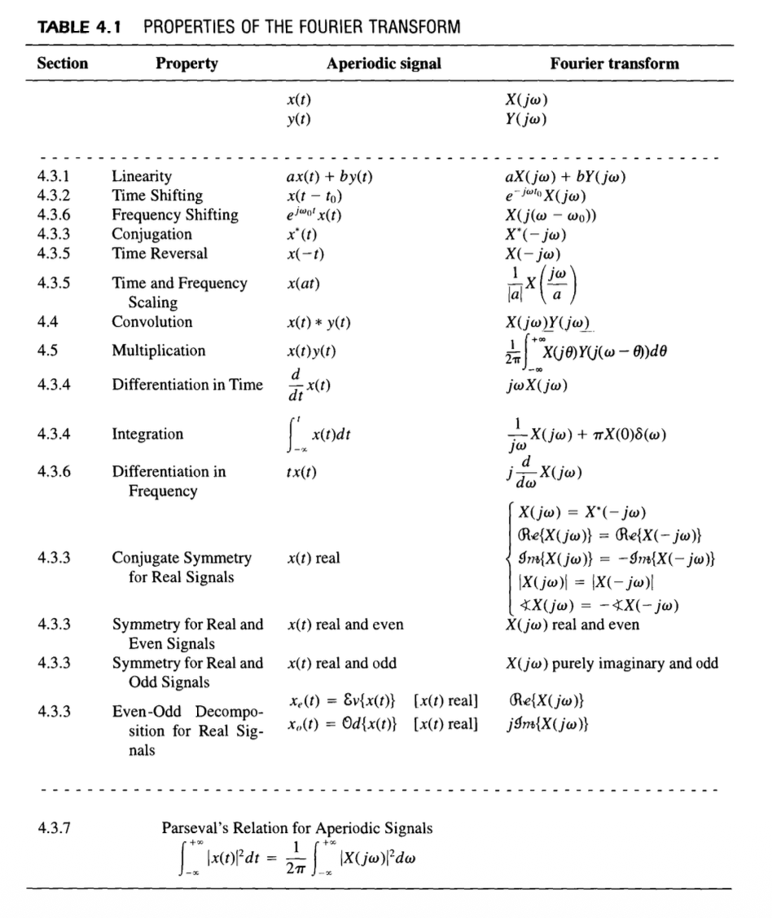

Continuous time Fourier transform table
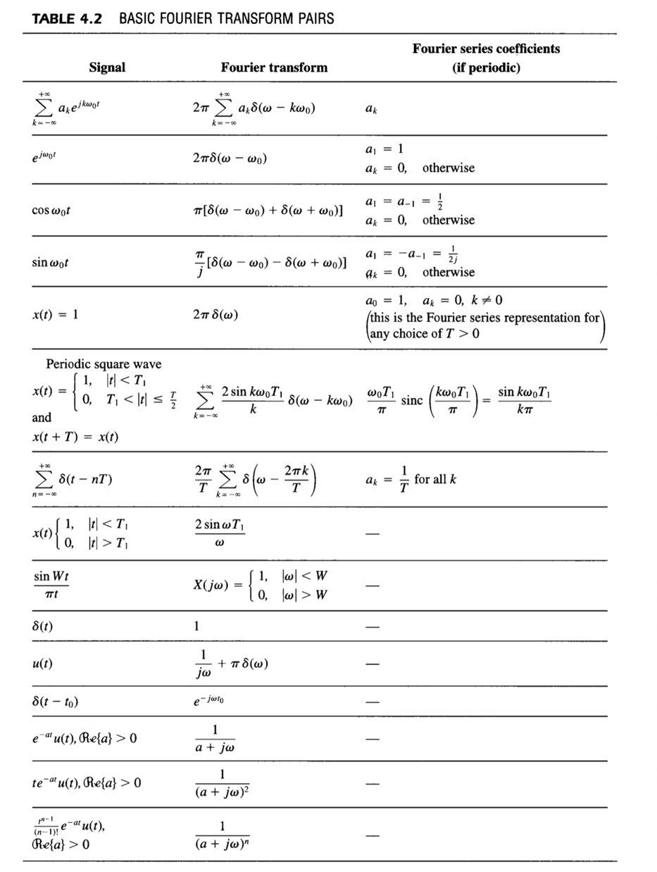

Discrete time Fourier transform properties
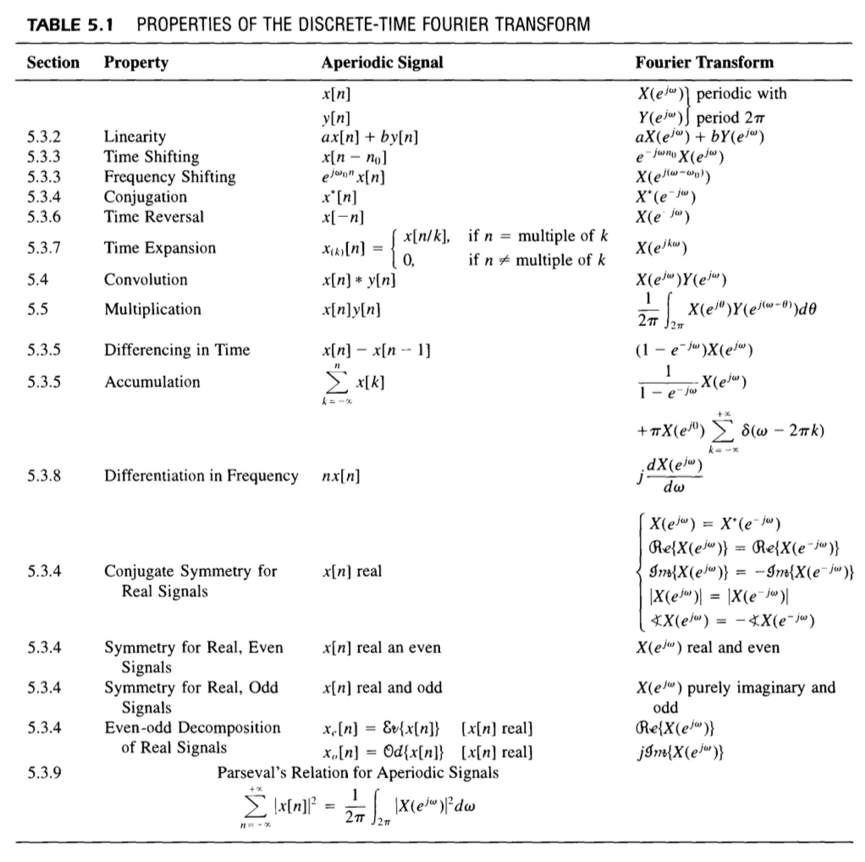

Discrete time Fourier transform table
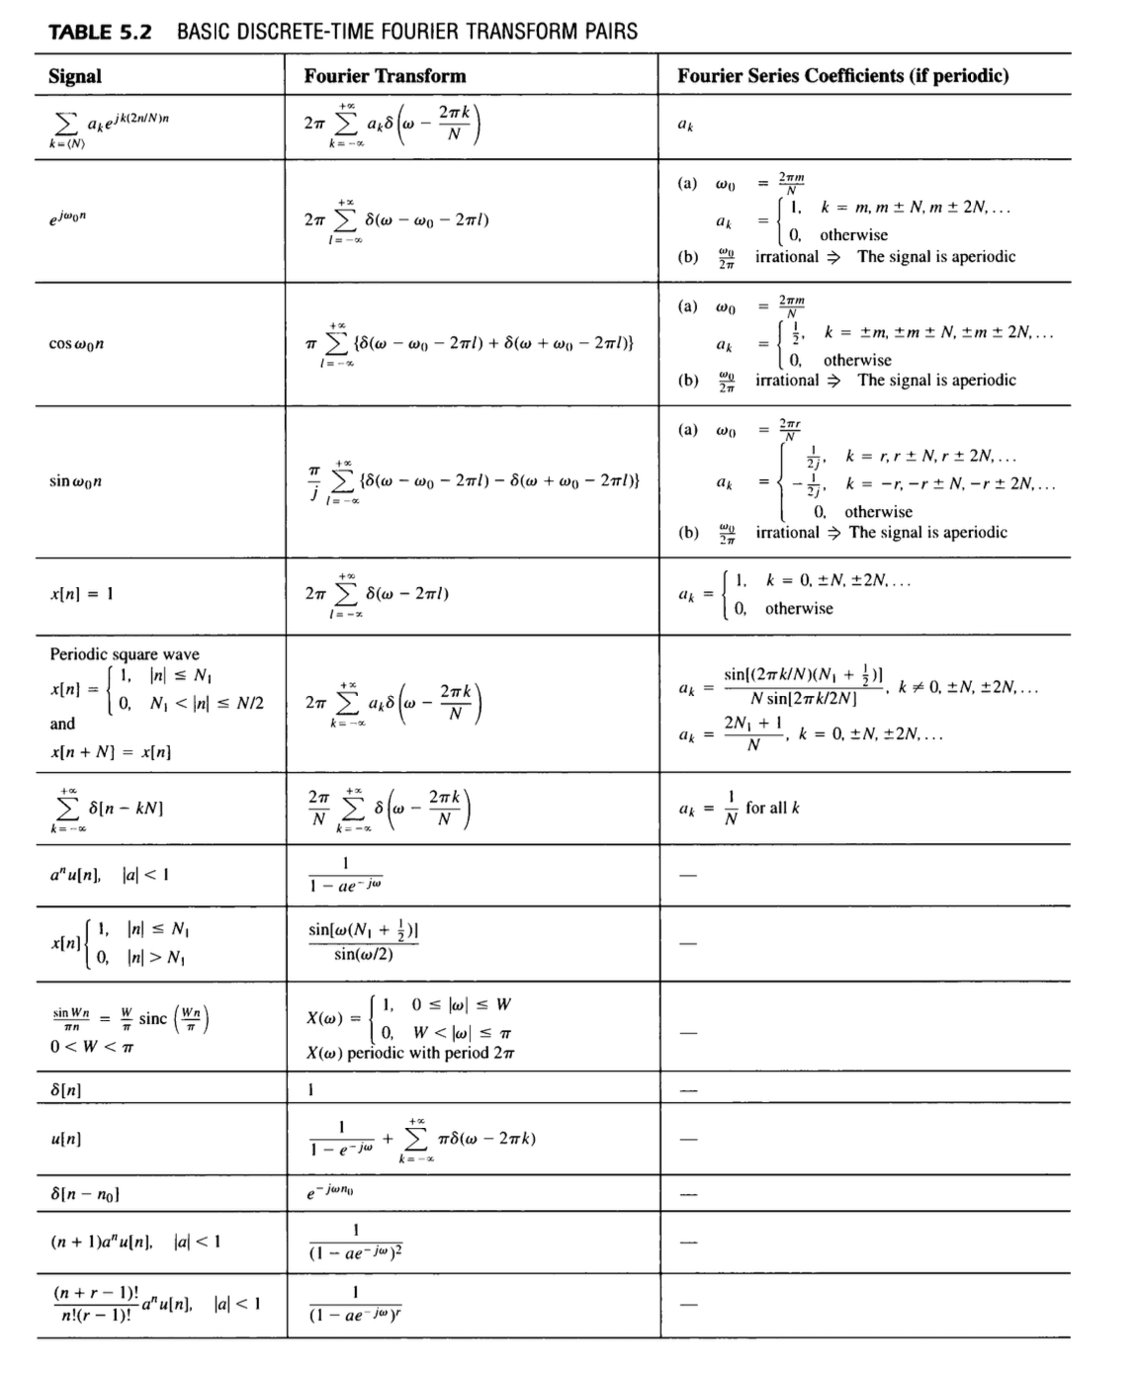

Fourier transform of a square wave.
Say we have a square wave having a 50% duty signal, operating at our modulated frequency. It’s a periodic function, which means, that we can calculate fourier series coefficients.
Say the period of it is T. During that time, it’s on for T/2 and off for T/2. The period is the inverse of the frequency of modulation, thus $\frac{1}{T}=f_{m}$, but also $\frac{T}{2}=\frac{\frac{1}{f_{m}}}{2}$.
Using equation 3.38 from the book on Signals and Systems, having two of its equation being found in the appendix under Fourier series representation, the coefficients can then be calculated by:
$$a\left(k\right)=f_{m}·\left(\int_{0}^{\frac{\frac{1}{f_{m}}}{2}}{v_{bias}\left(t\right)}e^{-j·k·2π·f_{m}·t}+\int_{\frac{\frac{1}{f_{m}}}{2}}^{\frac{1}{f_{m}}}{0·}e^{-j·k·2π·f_{m}·t}\right)$$
The bias can be approximated to just be constant at the time of being on.
$$a\left(k\right)=f_{m}·v_{bias}·\frac{1}{-j·k·2π·f_{m}}·{\left[e^{-j·k·2π·f_{m}·t}\right]}_{0}^{\frac{\frac{1}{f_{m}}}{2}} \\ a\left(k\right)=f_{m}·v_{bias}·\frac{\left(e^{-j·k·2π·f_{m}·\frac{1}{f_{m}}·\frac{1}{2}}-1\right)}{-j·k·2π·f_{m}}·\frac{j}{j}=\frac{v_{bias}}{k·2π}·\left(e^{-j·k·π}-1\right)j$$
$e^{-j·k·π}$ will either be 1 or -1 depending on whether it’s even or odd respectively.
$\frac{v_{bias}}{k·2π}·\left(1-1\right)j=0$
$\frac{v_{bias}}{k·2π}·\left(-1-1\right)j=2·\frac{v_{bias}}{k·2π}j=\frac{1}{k}·\frac{v_{bias}}{π}·j$
But cannot be used for DC frequency components when k = 0, due to singularities in the equation. Instead it’s found by revisiting the integrals.
$$a\left(0\right)=f_{m}·\left(\int_{0}^{\frac{\frac{1}{f_{m}}}{2}}{v_{bias}}e^{-j·0·2π·f_{m}·t}+\int_{\frac{\frac{1}{f_{m}}}{2}}^{\frac{1}{f_{m}}}{0·}e^{-j·0·2π·f_{m}·t}\right) \\ a\left(0\right)=f_{m}·\int_{0}^{\frac{\frac{1}{f_{m}}}{2}}{v_{bias}}=f_{m}·\frac{\frac{1}{f_{m}}}{2}·v_{Bias}=\frac{v_{Bias}}{2}$$
$$a\left(k\right)=\left\{\begin{aligned} 0, k≠0 and even \\ \frac{1}{k}·\frac{v_{Bias}}{π}·j, k≠0 and odd \\ \frac{v_{Bias}}{2}, k=0 \end{aligned}\right\}$$
From the attachment on the Fourier transform table, it’s seen that the fourier coefficient has a constant factor of $2π$ multiplied to them, as well as having impulses at $kω_{0}$.
$$X\left(jω\right)\left(a\right)=2π·\left\{\begin{aligned} 0, k≠0 and even \\ \frac{1}{k}·\frac{v_{Bias}}{π}·j, k≠0 and odd \\ \frac{v_{Bias}}{2}, k=0 \end{aligned}\right\}·δ\left(ω-kω_{0}\right) \\ X\left(jω\right)\left(a\right)=\left\{\begin{aligned} 0, k≠0 and even \\ \frac{2v_{Bias}}{k}·j, k≠0 and odd \\ π·v_{Bias}, k=0 \end{aligned}\right\}·δ\left(ω-kω_{0}\right)$$And in terms of magnitude- and phase response.
$$\left|X\left(jω\right)\right|=\left\{\begin{aligned} 0, k≠0 and even \\ \frac{2v_{Bias}}{k}, k≠0 and odd \\ π·v_{Bias}, k=0 \end{aligned}\right\}·δ\left(ω-kω_{0}\right)$$
And in terms of it’s phase, only a phase outside of $ω=0$ exists whilst also only odd.
$\frac{2v_{Bias}}{k}·j$ can also be written as $-\frac{2v_{Bias}}{\left|k\right|}·j=j^{2}·\frac{2v_{Bias}}{\left|k\right|}·j$, for the negative k values. The complex j corresponds to a phase shift of 90°.
$j=e^{\frac{jπ}{2}}, j·j^{2}=e^{\frac{jπ}{2}}·e^{jπ} =e^{\frac{3jπ}{2}}=e^{-\frac{jπ}{2}}$
That makes the phase response be:
$$∠X\left(jω\right)=\left\{\begin{aligned}-90°, ω<0 \\ 90°, ω>0\end{aligned}\right\}$$With a discontinuousy at $ω=0$.

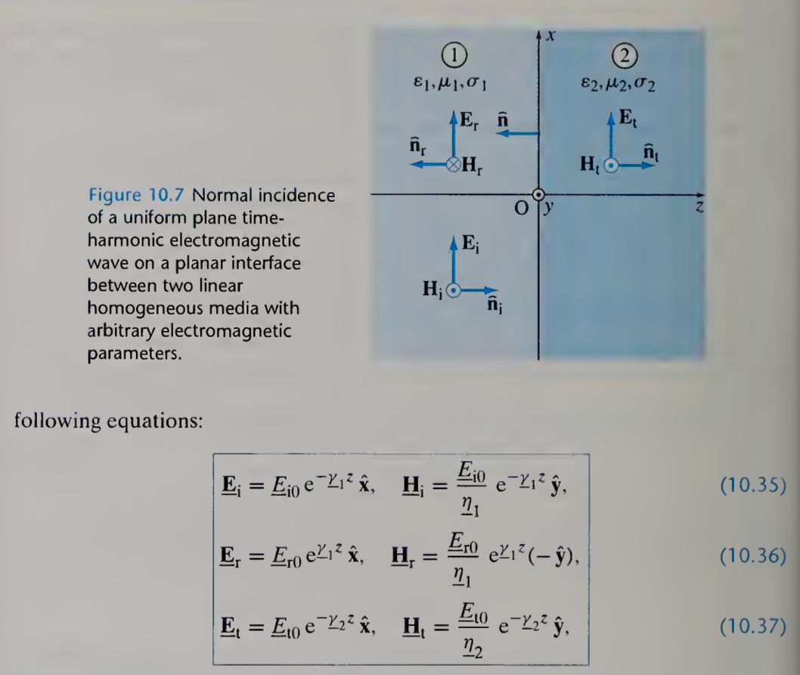
Electromagnetic waves passing through uniform plane.



